<https://www.youtube.com/watch?v=8b1JEDvenQU&list=PLblh5JKOoLUICTaGLRoHQDuF_7q2GfuJF&index=60>



Today we're gonna talk about XGBoost part 2 XGBoost trees for classification.

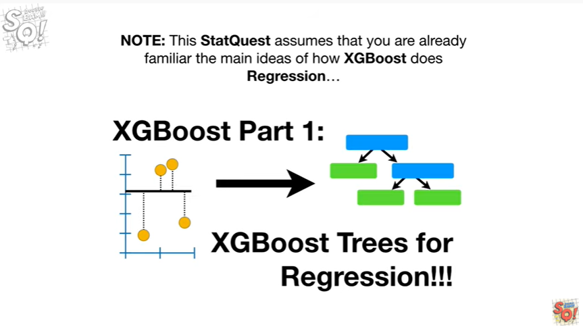

Note : this stack quest assumes that you are already familiar with the main ideas of how XGBoost does regression

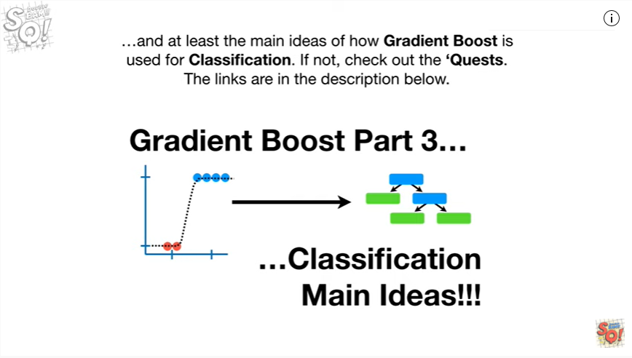

and at least the main ideas of how gradient boost is used for classification.

If not check out the quests, the links are in the description below.

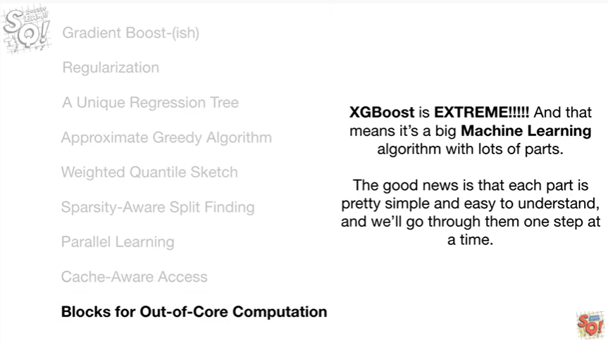

XGBoost is extreme !!!

And that means it's a big machine learning algorithm with lots of parts.

The good news is that each part is pretty simple and easy to understand, and we'll go through them one step at a time.

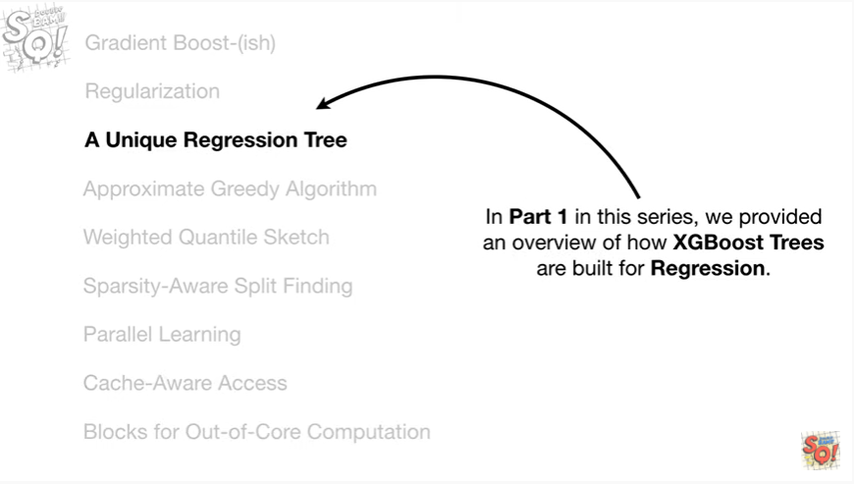

In part one in this series, we provided an overview of how XGBoost trees are built for regression.

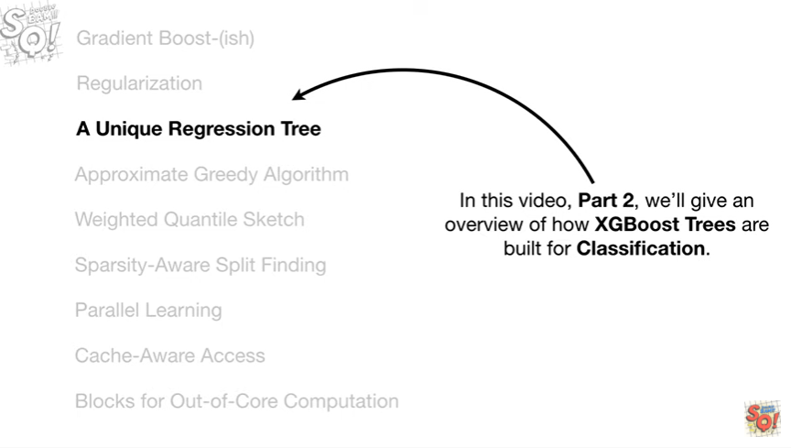

In this video, part two, we'll give an overview of how XGBoost trees are built for classification.

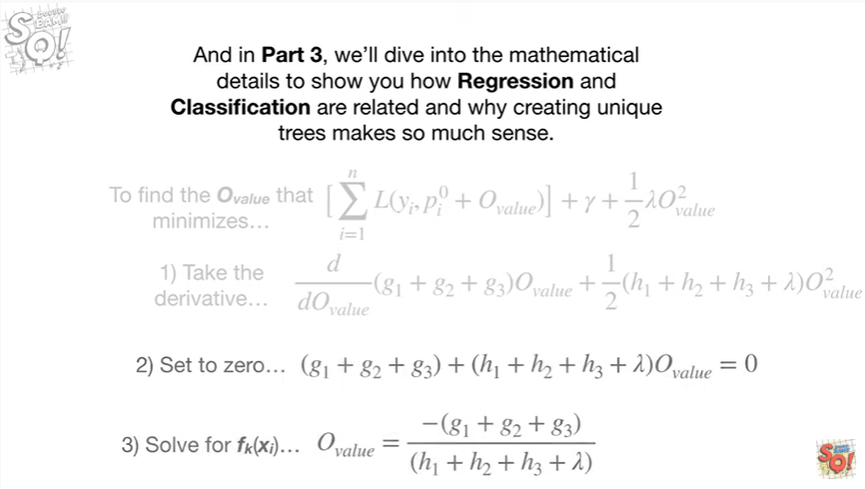

And in part three, we'll dive into the mathematical details to show you how regression and classification are related and why creating unique trees makes so much sense.

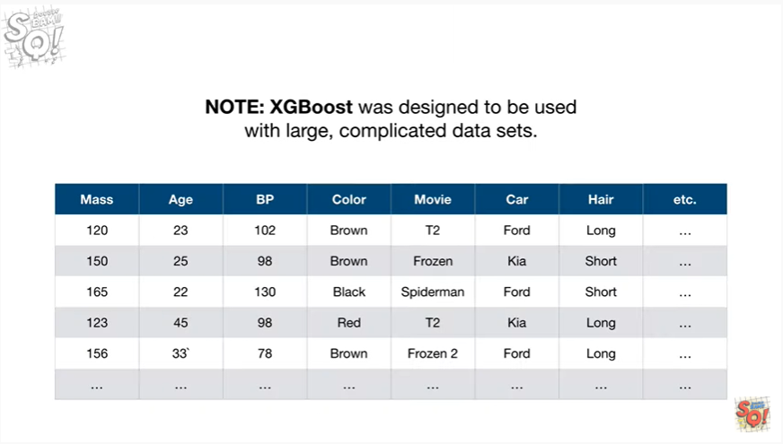

Note : XGBoost was designed to be used with large complicated data sets.

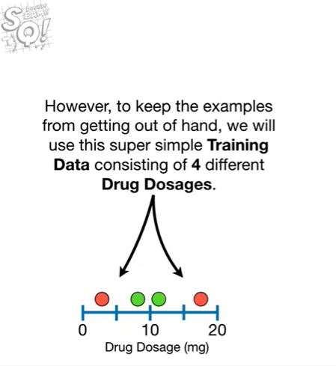

However, to keep the examples from getting out of hand, we will use this super simple training data consisting of four different drug dosages.

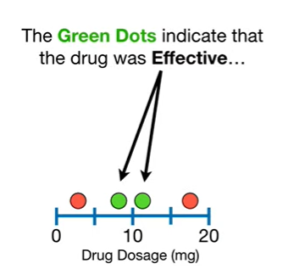

The green dots indicate the drug was effective

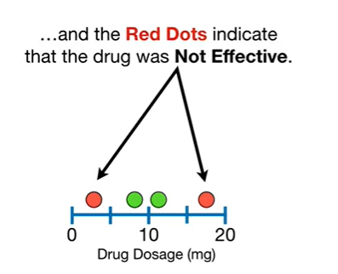

and the red dots indicate that the drug was not effective.

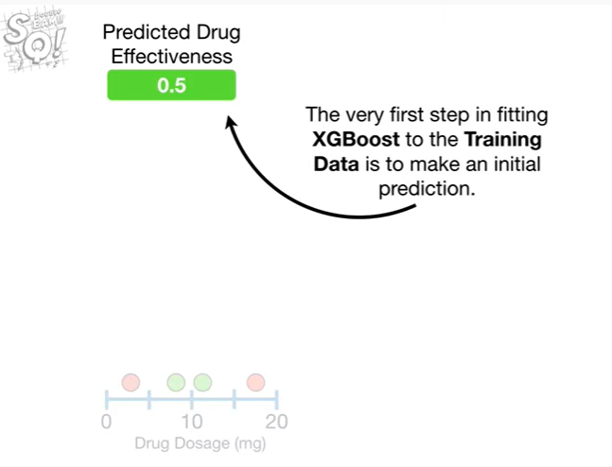

The very first step in fitting XGBoosts to training data is to make an initial prediction.

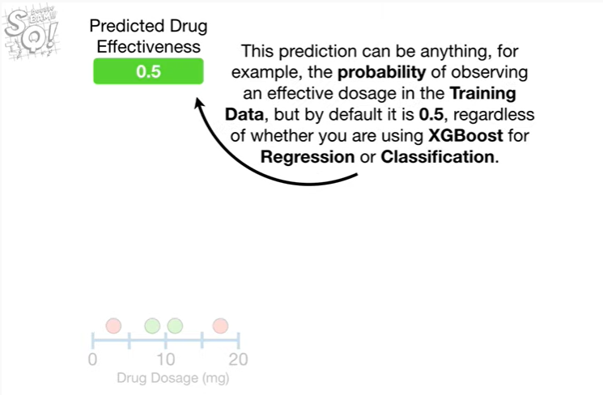

This prediction can be anything, for example, the probability of observing an effective dosage in the training data, but by default it is 0.5, regardless of whether you are using XGBoost for regression or classification.

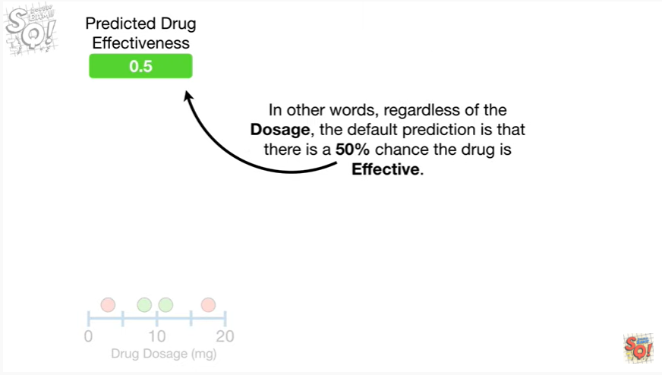

In other words, regardless of the dosage, the default prediction is that there is a 50% chance the drug is effective.

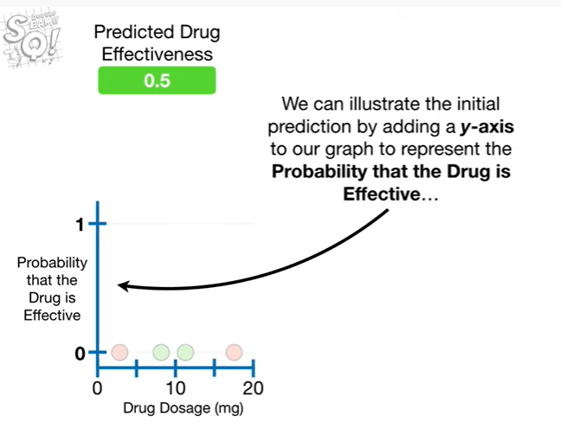

We can illustrate the initial prediction by adding a y access to our graph to represent the probability that the drug is effective

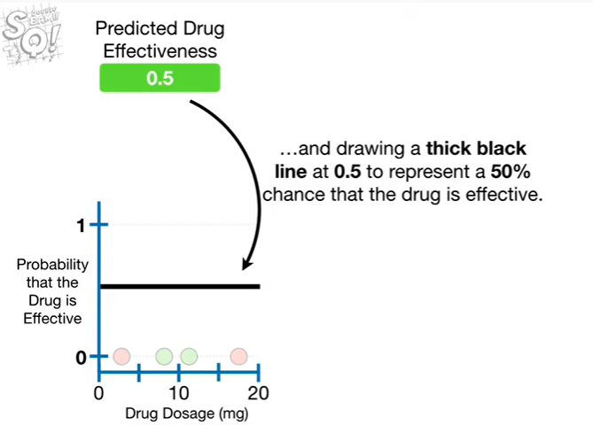

and drawing a thick black line at 0.5 to represent a 50% chance that the drug is effective.

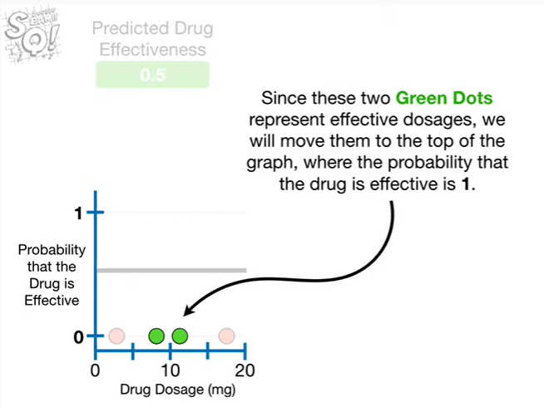

Since these two green dots represent effective dosages, we will move them to the top of the graph where the probability that the drug is effective is 1.

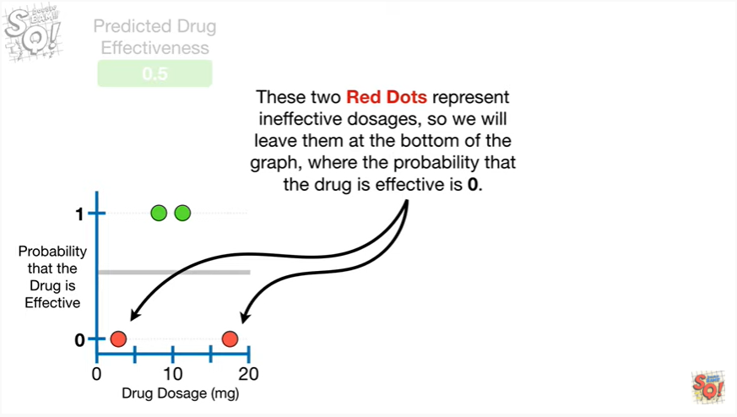

These two red dots represent ineffective dosage,s so we will leave them at the bottom of the graph, where the probability that the drug is effective is zero.

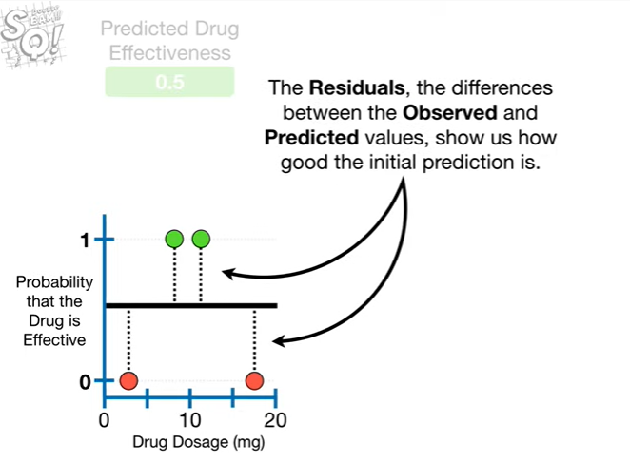

The residuals the differences between the observed and predicted values, show us how good the initial prediction is.

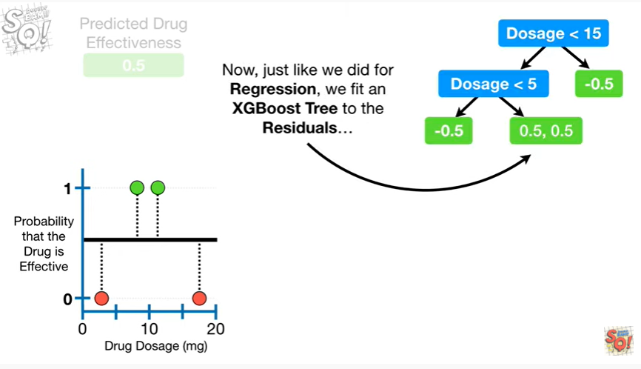

Now, just like we did for regression, we fit an XGBoost tree to the residuals

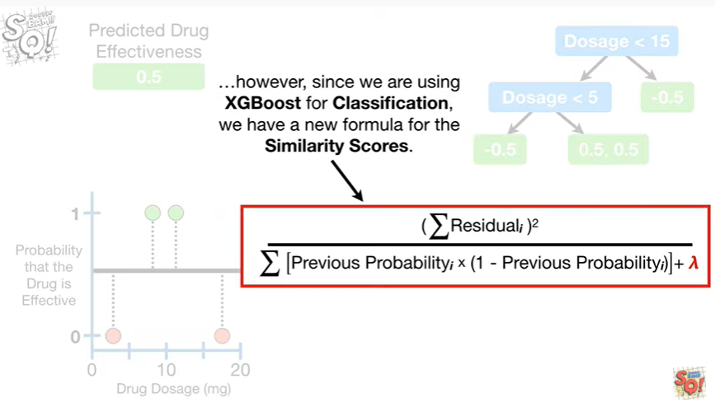

However, since we are using XGBoost for classification we have a new formula for the similarity scores.

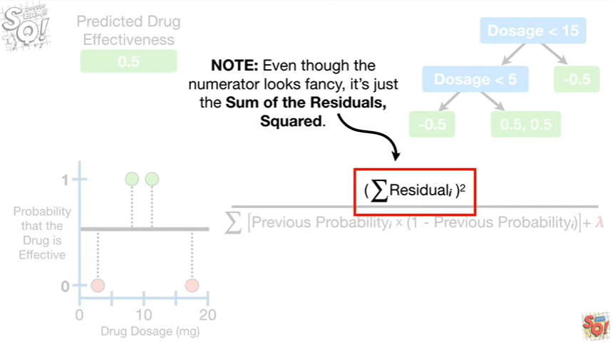

Note : even though the numerator looks fancy it's just the sum of the residuals squared.

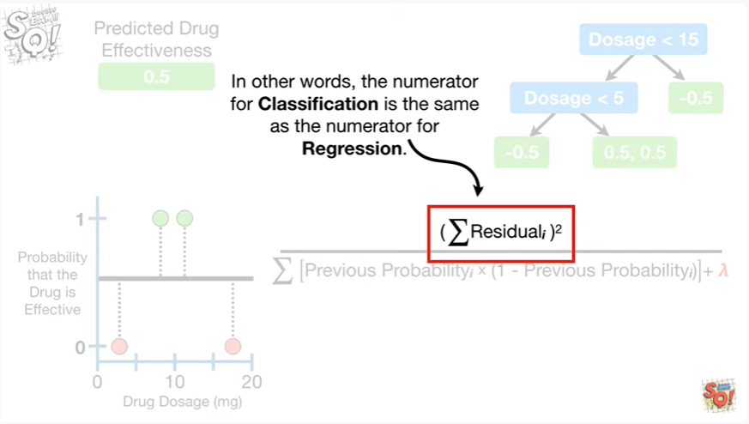

In other words the numerator for classification is the same as the numerator for regression.

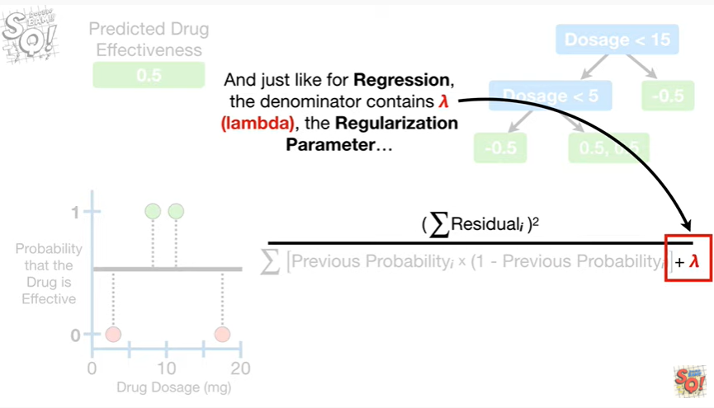

And just like for regression, the denominator contains lambda, the regularization parameter

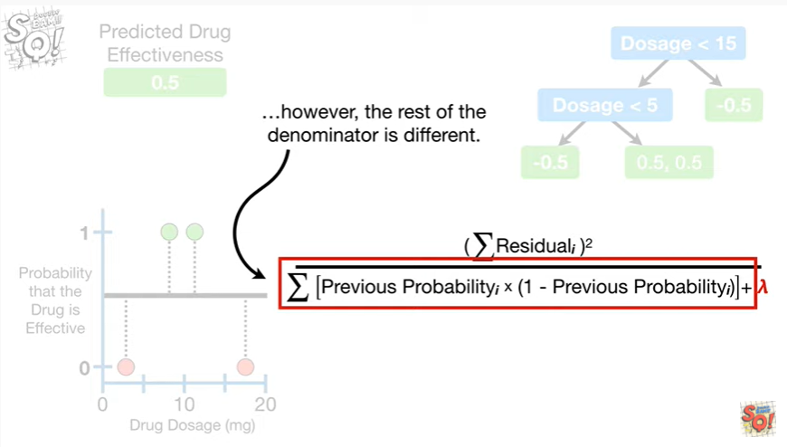

however the rest of the denominator is different.

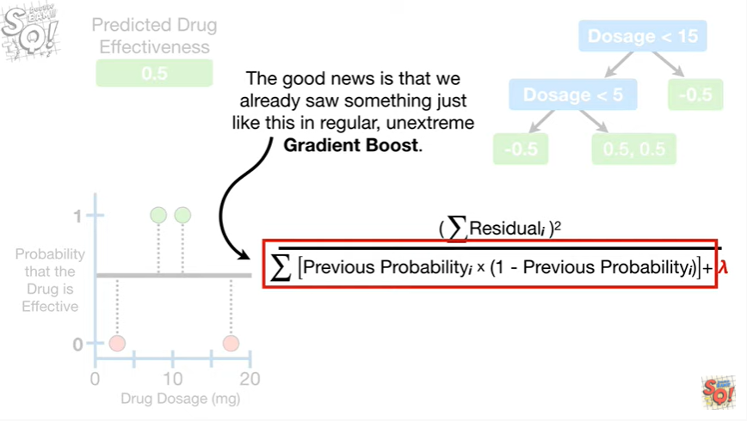

The good news is that we already saw something just like this in regular, unextreme gradient boost.

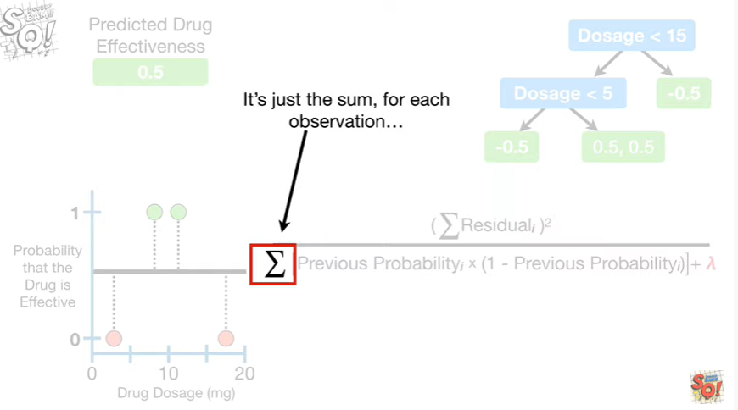

It's just the sum for each observation

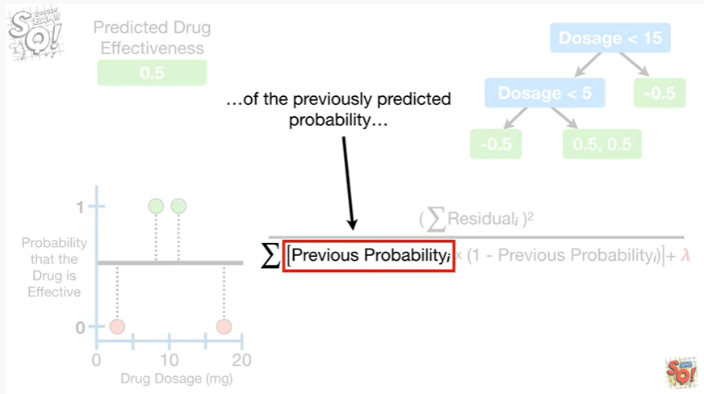

of the previously predicted probability

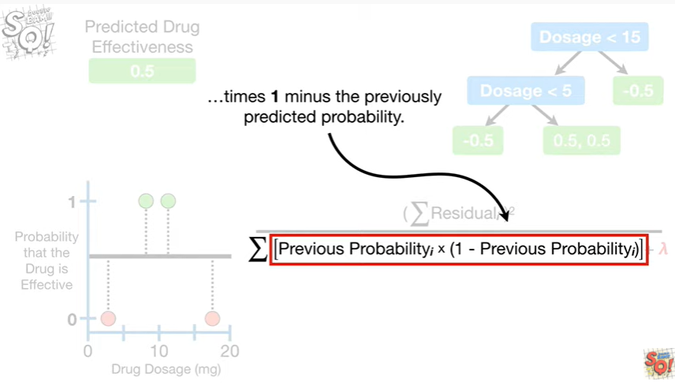

times (1 minus the previously predicted probability).

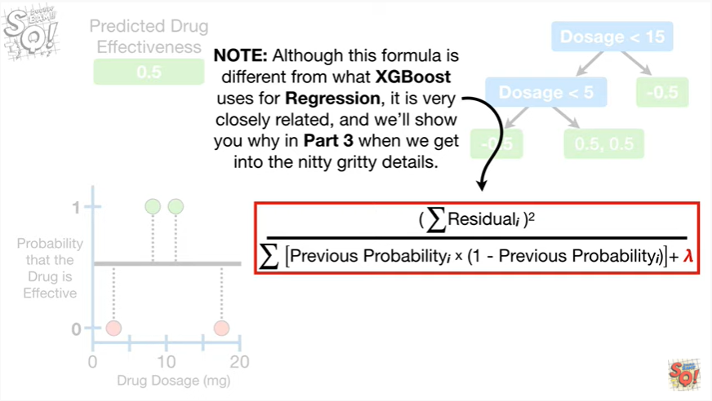

Note : although this formula is different from what XGBoost uses for regression, it is very closely related, and we will show you why in part 3, when we get into the nitty-gritty details.

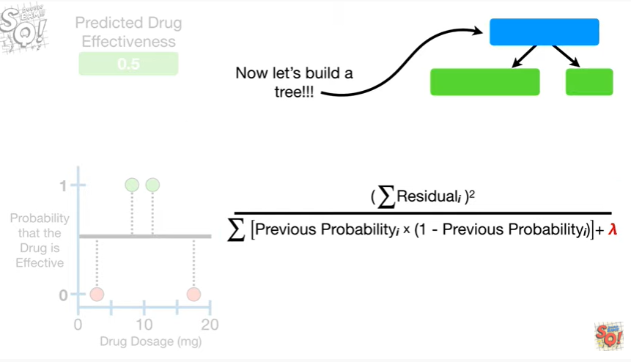

Now let's build a tree !!!

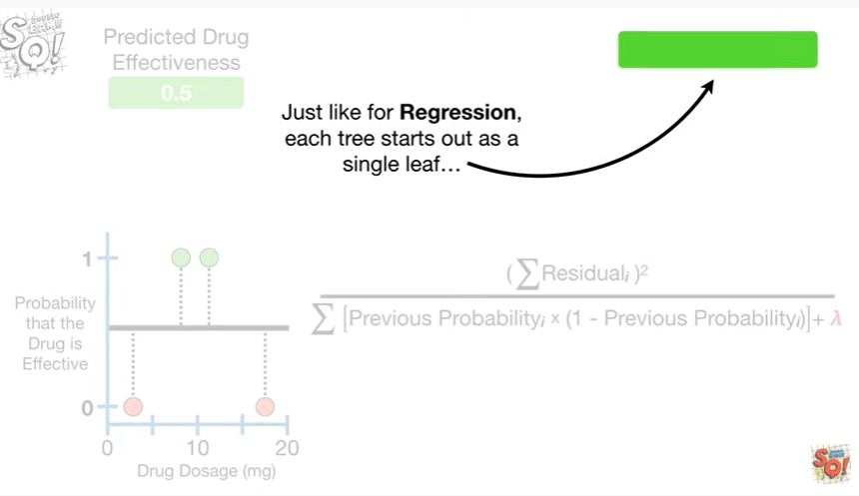

Just like for regression each tree starts out as a single leaf

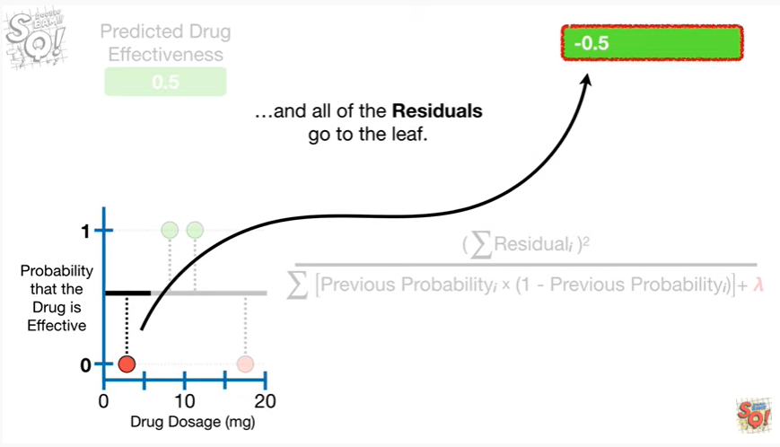

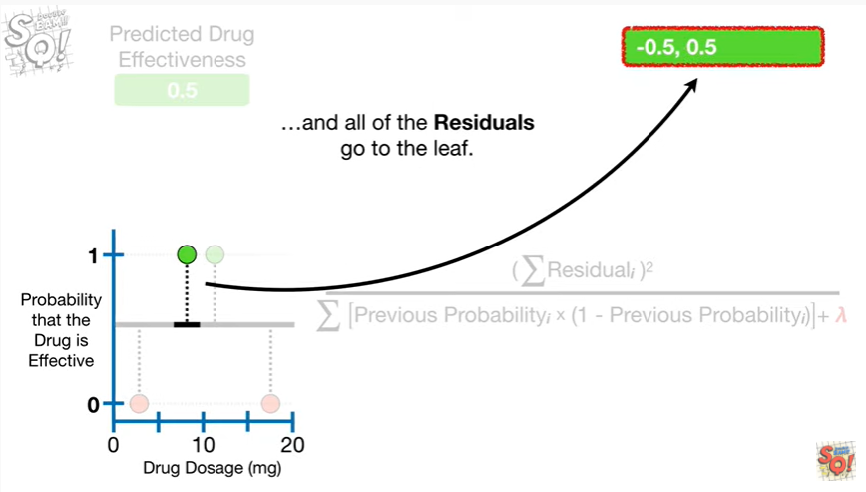

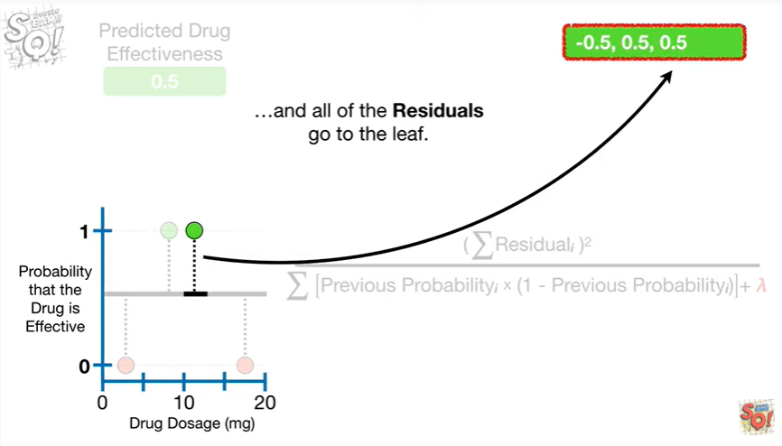

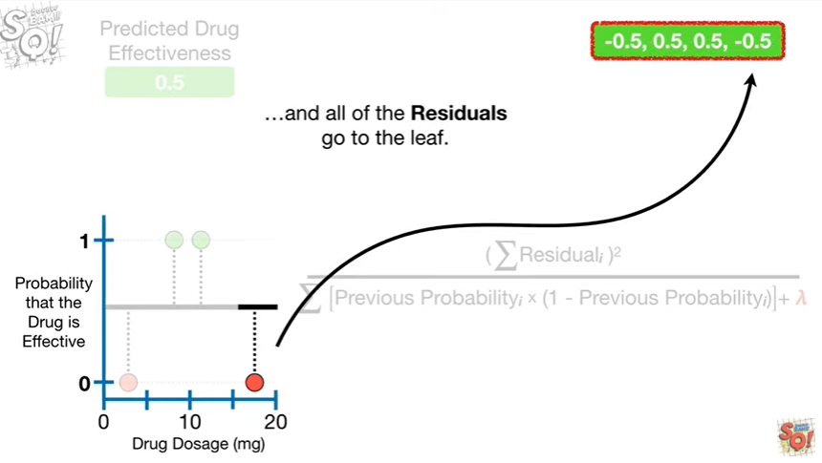

and all of the residuals go to the leaf.

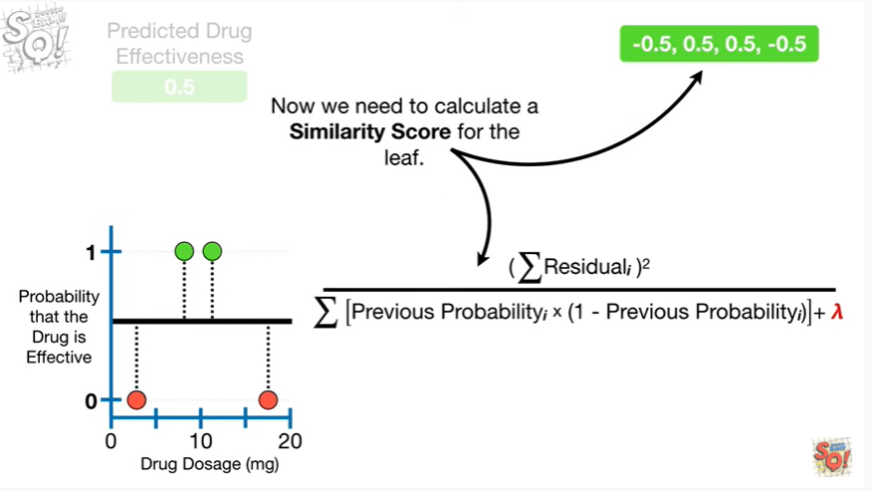

Now we need to calculate a similarity score for the leaf.

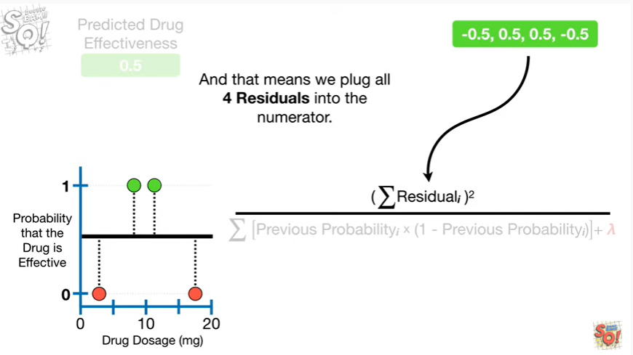

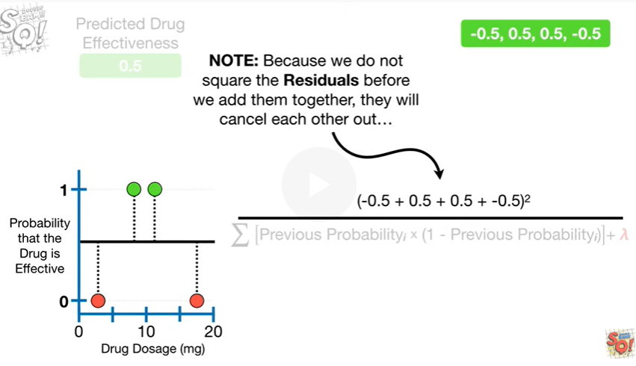

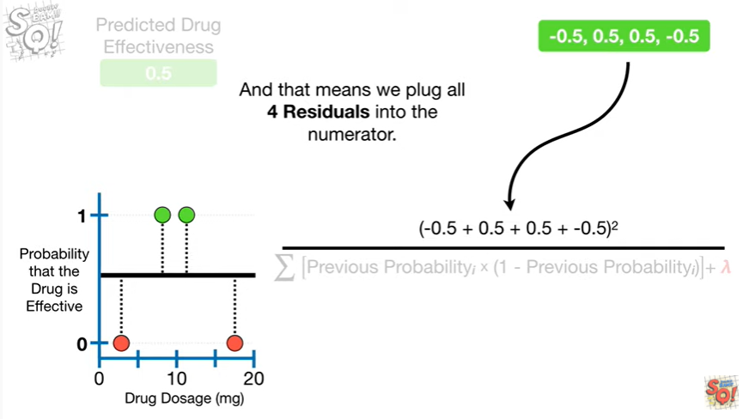

And that means we plug all four residuals into the numerator.

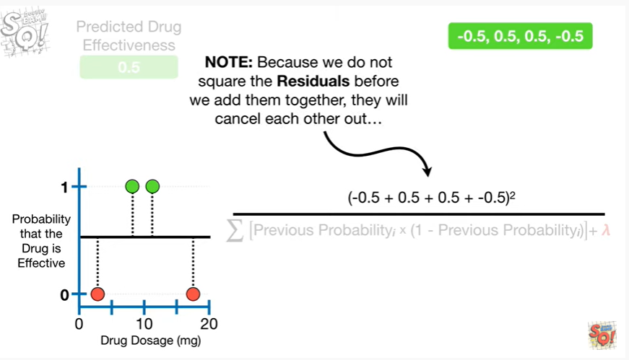

Note : because we do not square the residuals before we add them together

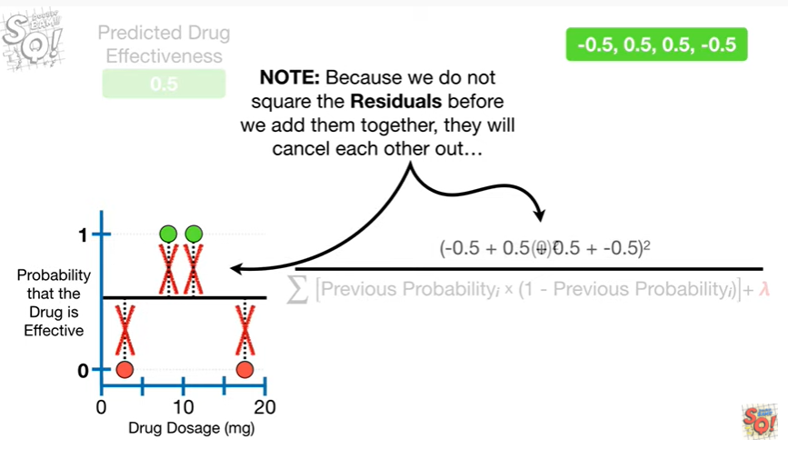

they will cancel each other out

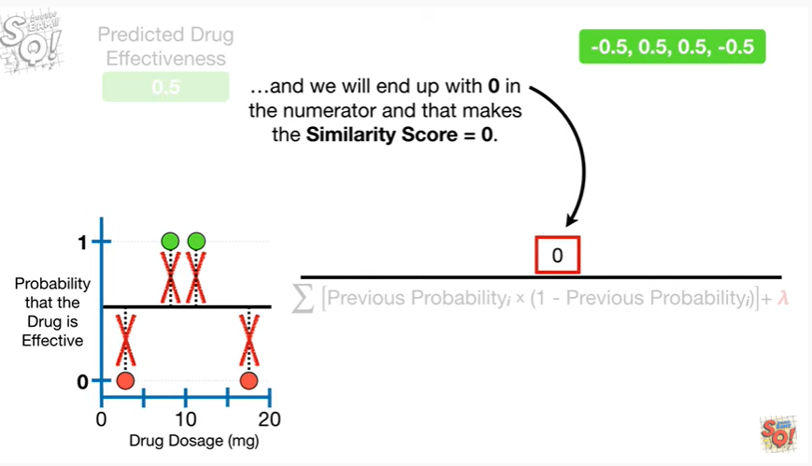

and we will end up with zero in the numerator and that makes the similarity score equal to zero.

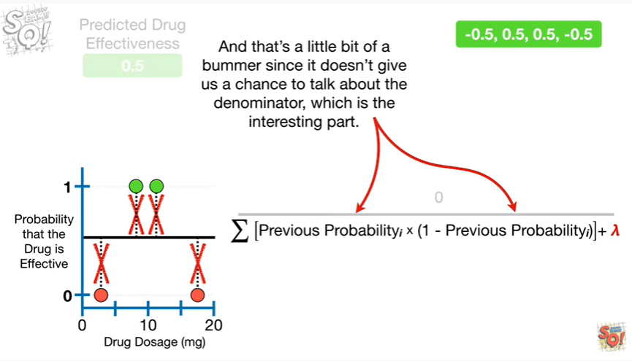

And that's a little bit of a bummer, since it doesn't give us a chance to talk about the denominato,r which is the interesting part.

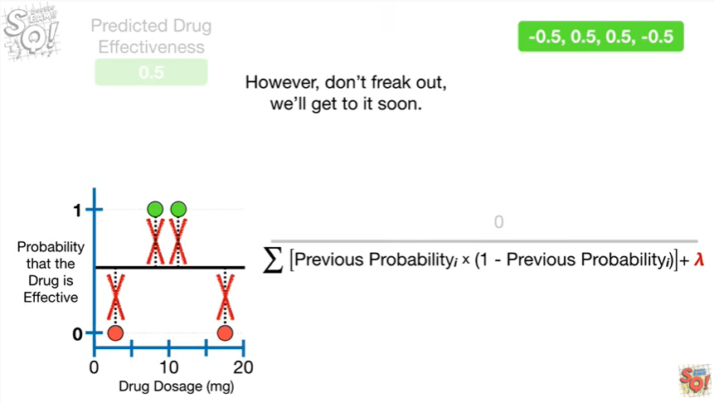

However, don't freak out we'll get to it soon.

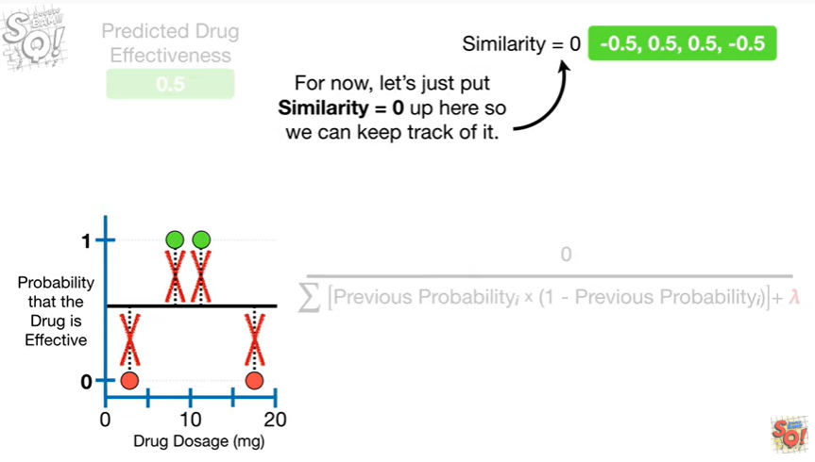

For now, let's just put similarity equals zero up here so we can keep track of it.

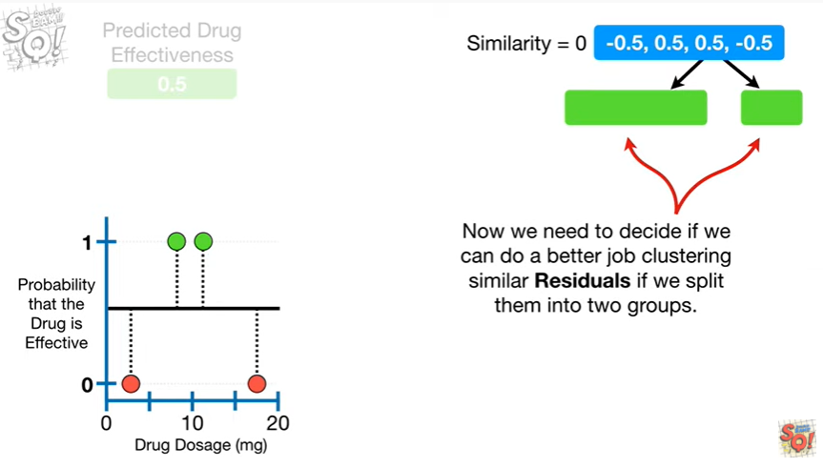

Now we need to decide if we can do a better job clustering similar residuals if we split them into two groups.

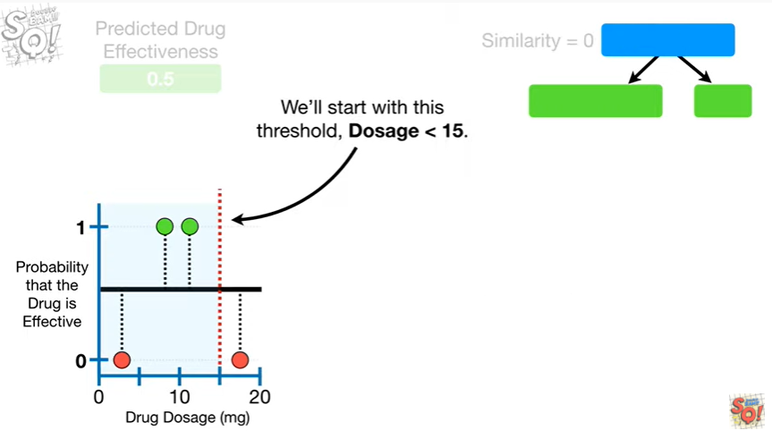

We'll start with this threshold, dosage less than 15.

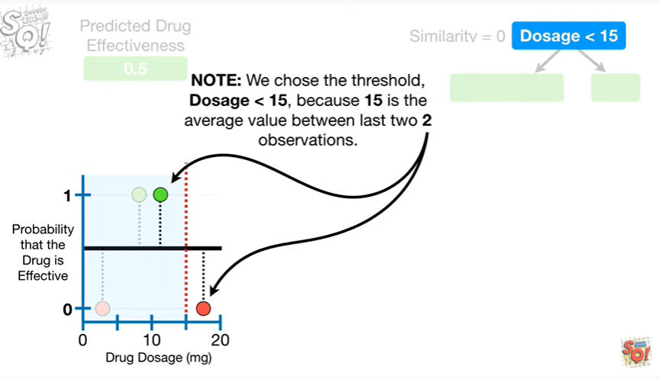

Note : we chose the threshold dosage less than 15 because 15 is the average value between the last two observations.

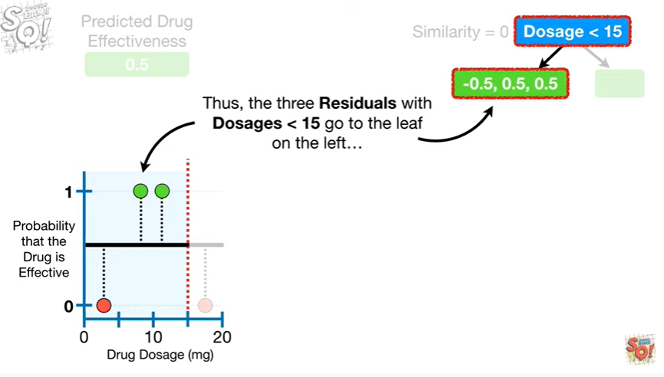

Thus, the three residuals with dosage is less than 15 go to the leaf on the left

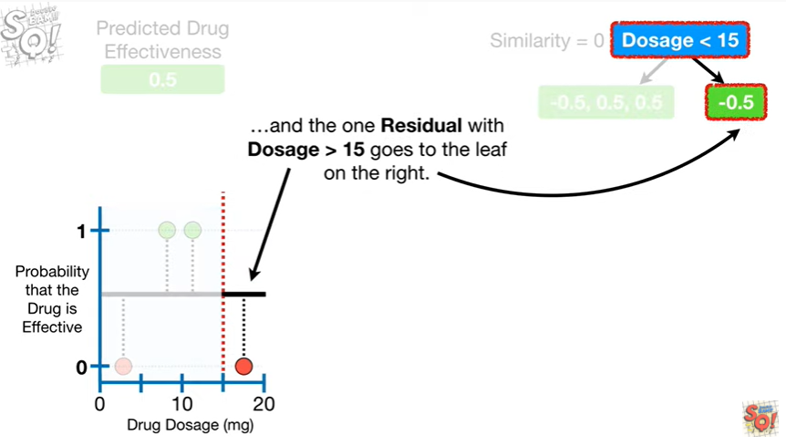

and the one residual with dosage greater than 15 goes to the leaf on the right.

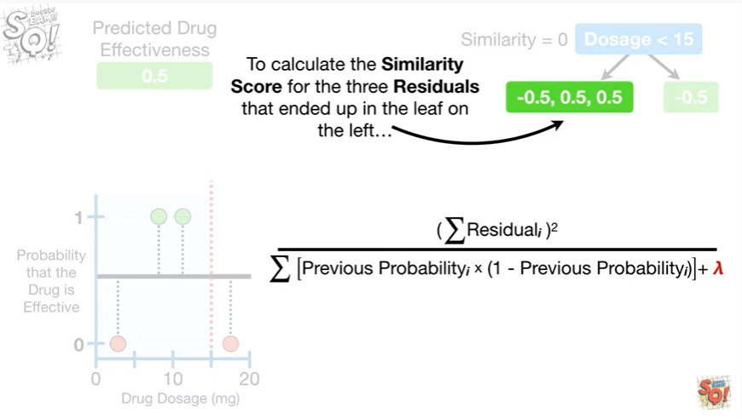

To calculate the similarity score for the three residuals that ended up in the leaf on the Left

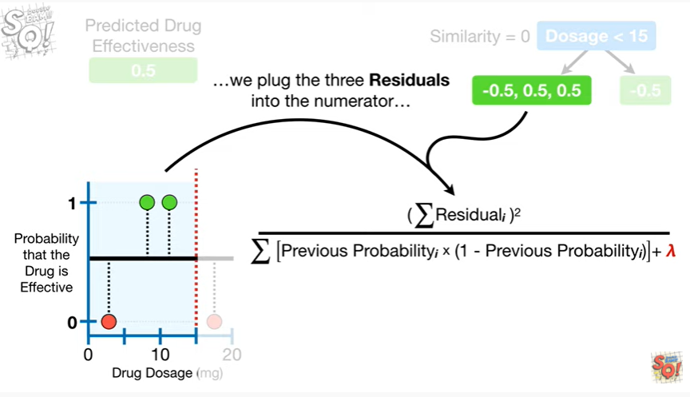

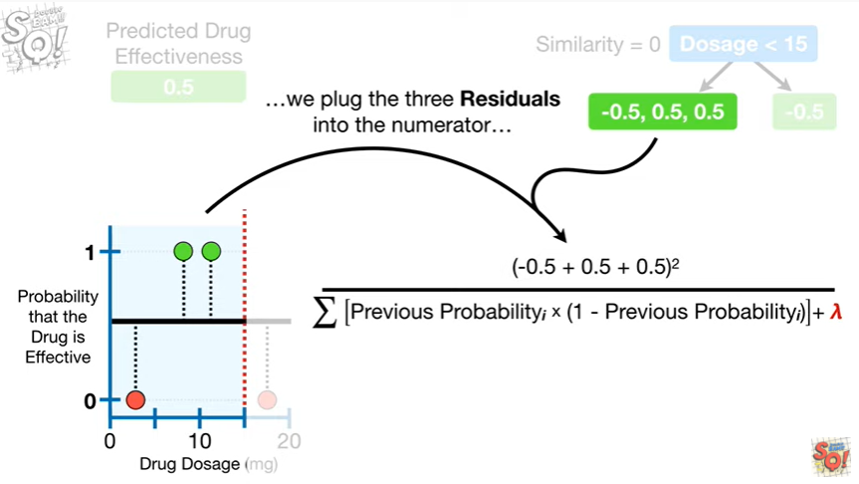

we plug the three residuals into the numerator

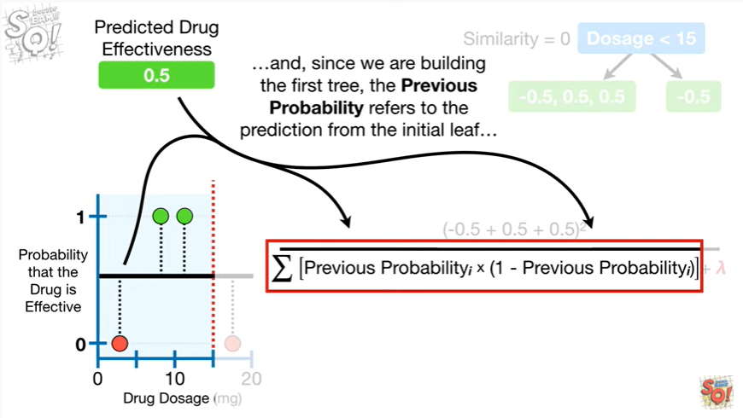

And, since we are building the first tree, the previous probability refers to the prediction from the initial leaf

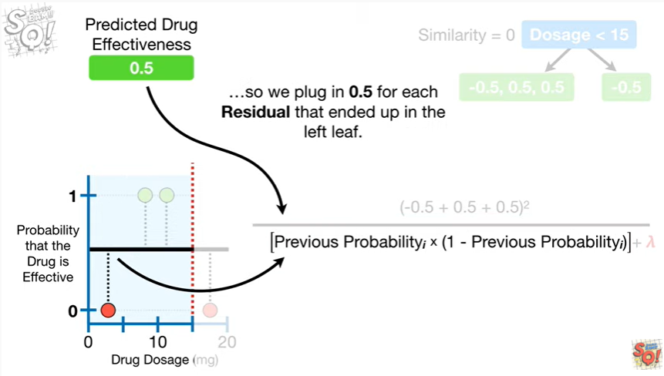

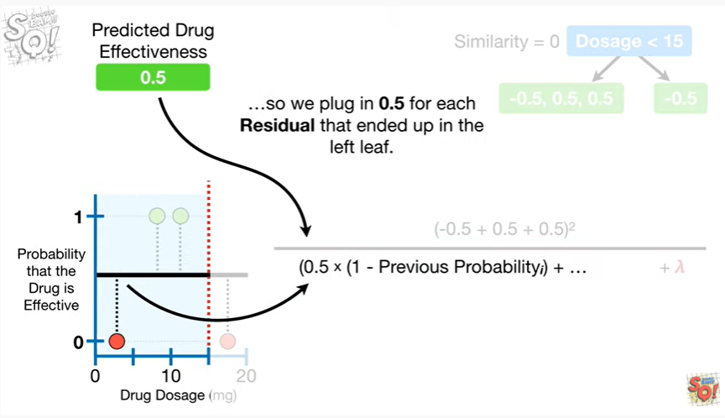

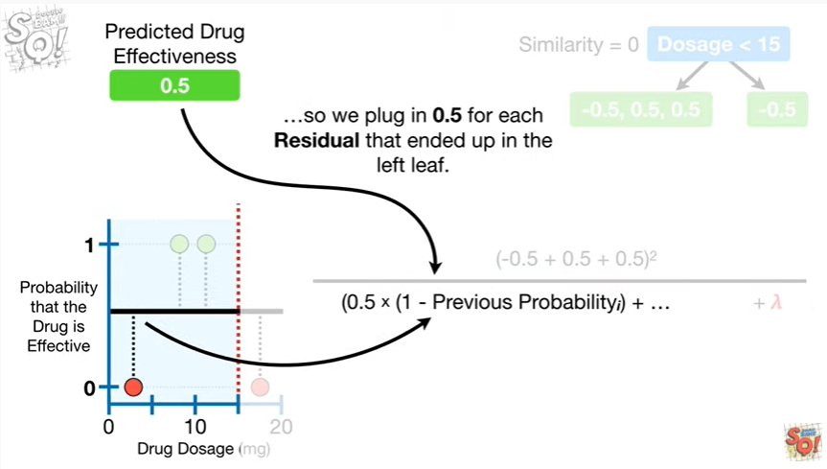

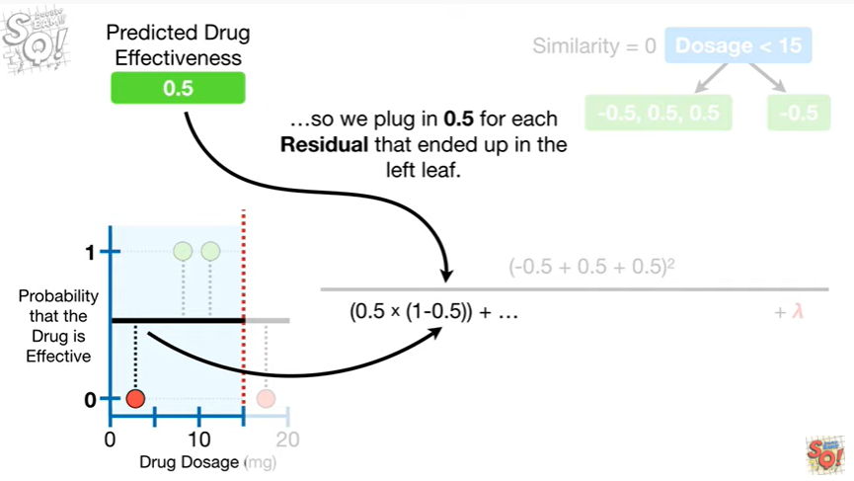

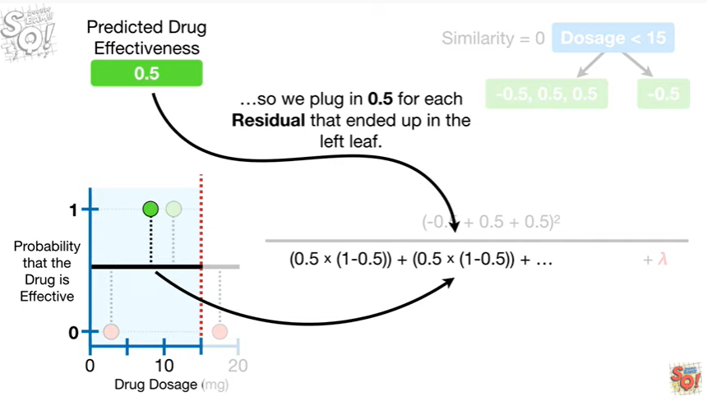

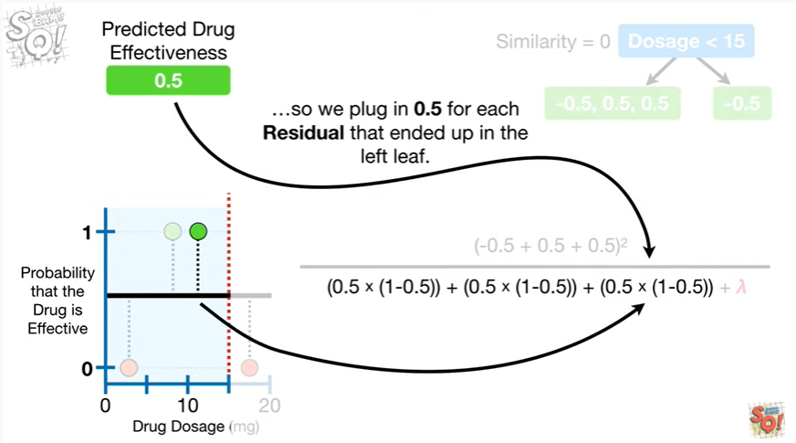

so we plug in zero point five for each residual that ended up in the leaf.

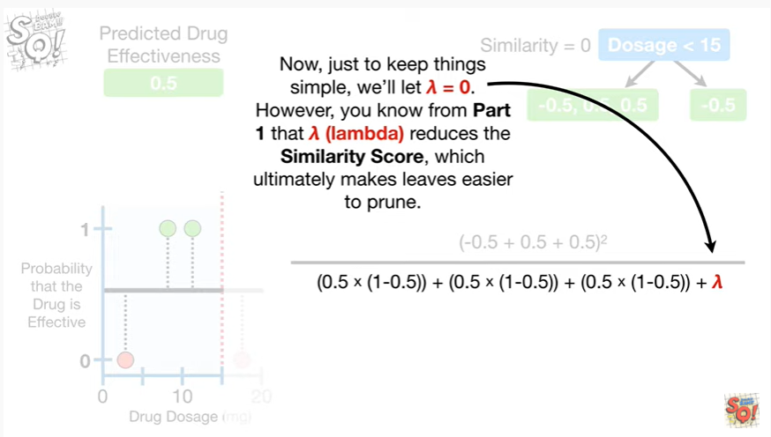

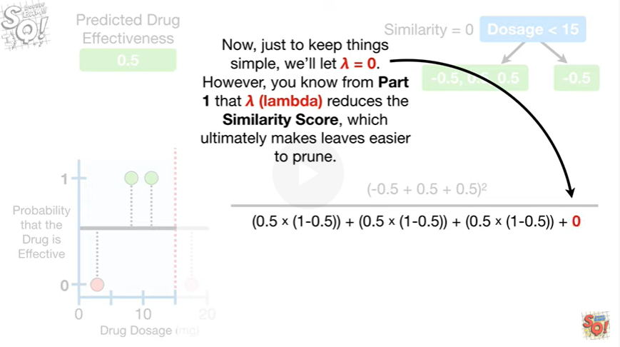

Now, just to keep things simple we'll let lambda equal zero.

However, you know from part one that lambda reduces the similarity score, which ultimately makes leaves easier to prune.

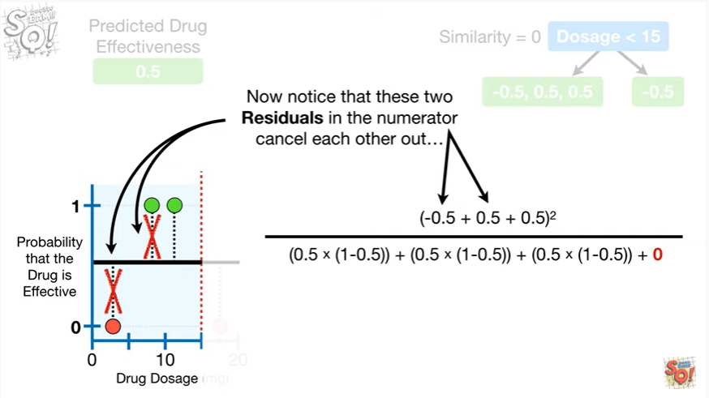

Now notice that these two residuals in the numerator cancel each other out

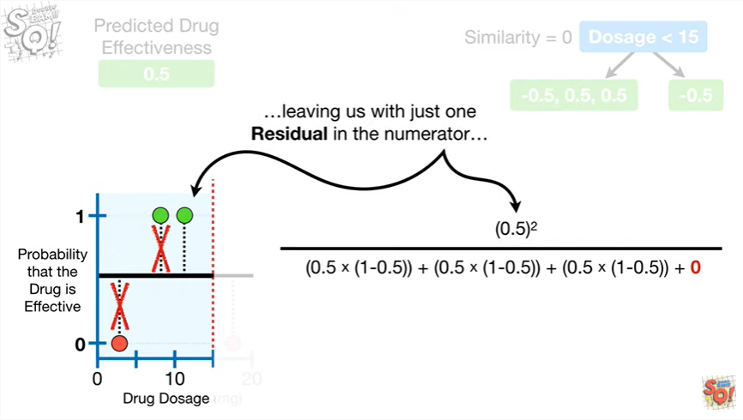

leaving us with just one residual in the numerator

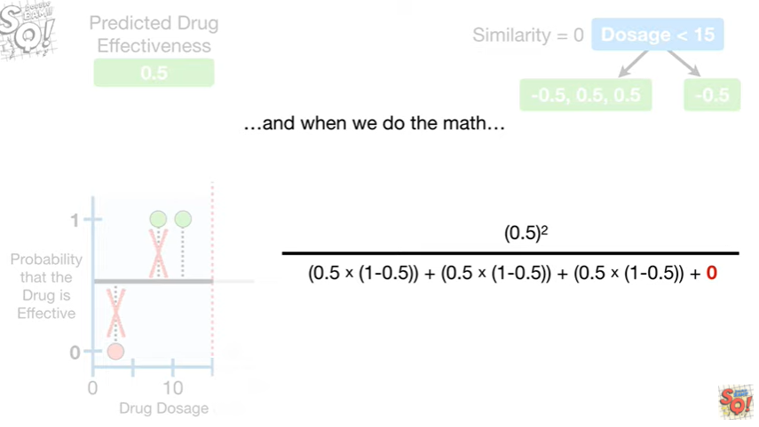

and when we do the math

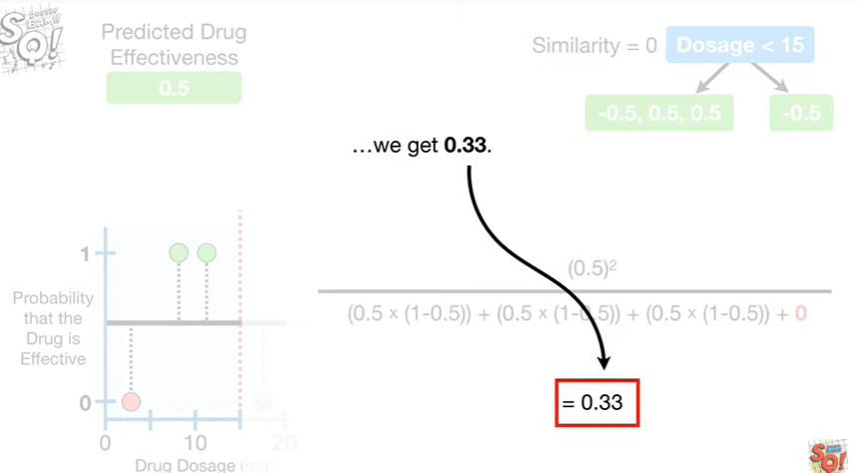

we get 0.33.

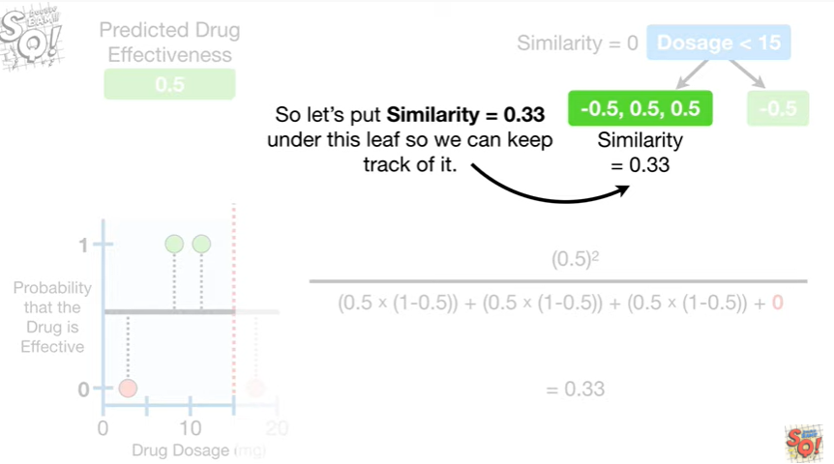

So let's put similarity equals 0.33 under this leaf so we can keep track of it.

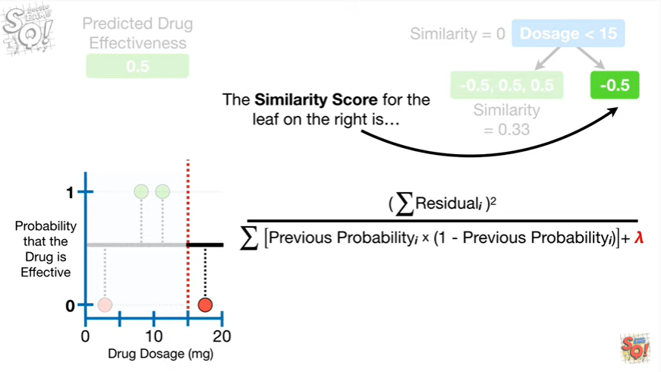

The similarity score for the leaf on the right is

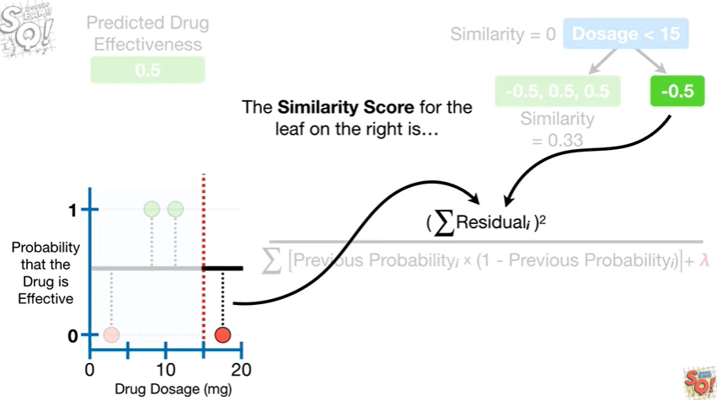

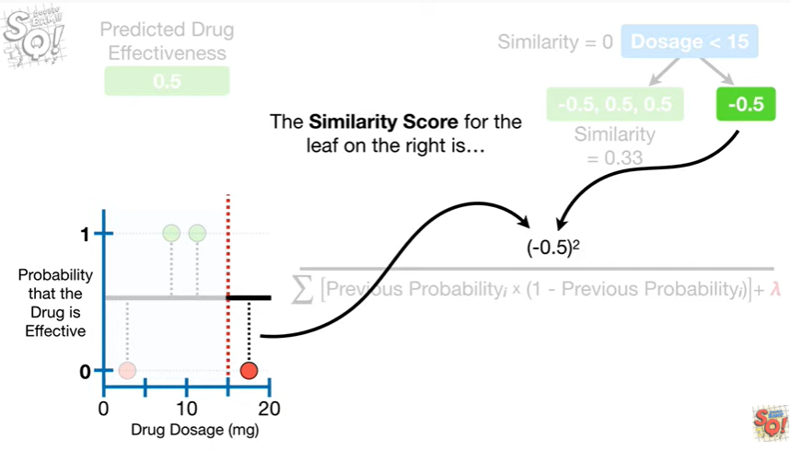

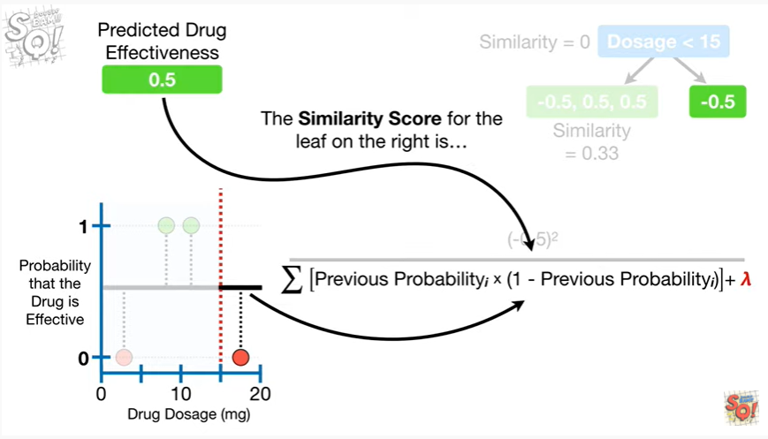

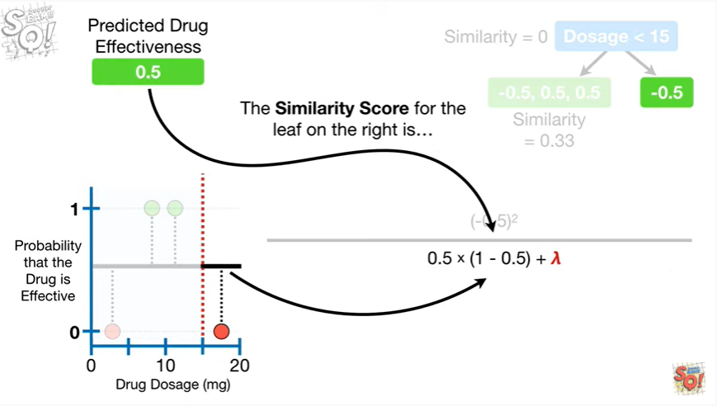

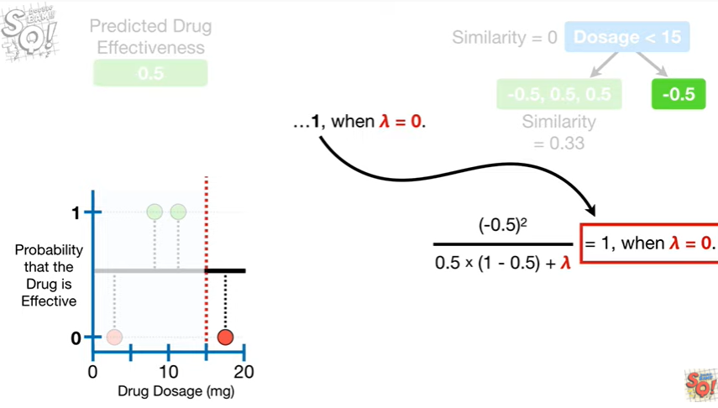

1, when lambda equals zero.

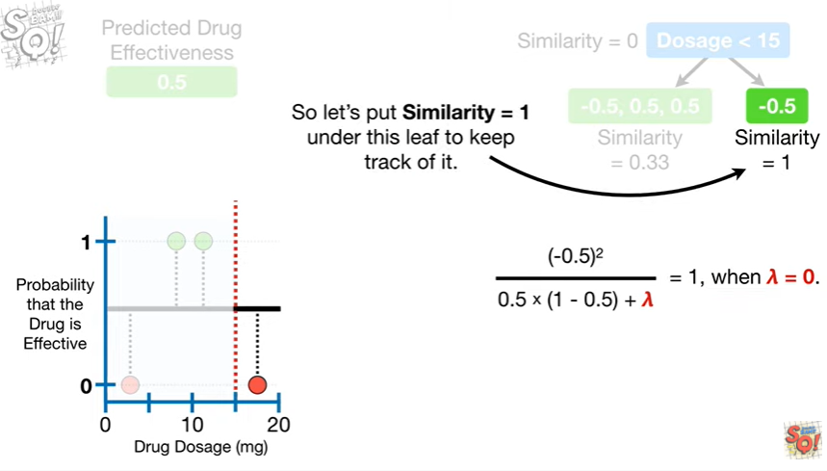

So let's put similarity equals 1 under this leaf to keep track of it.

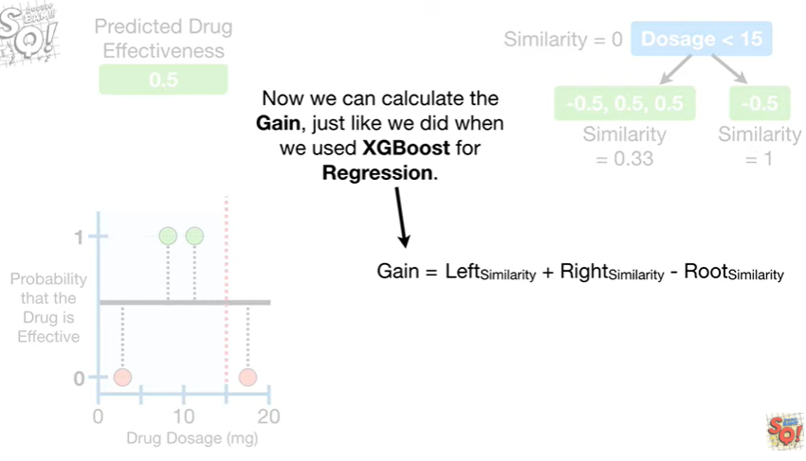

Now we can calculate the gain just like we did when we used XGBoost for regression.

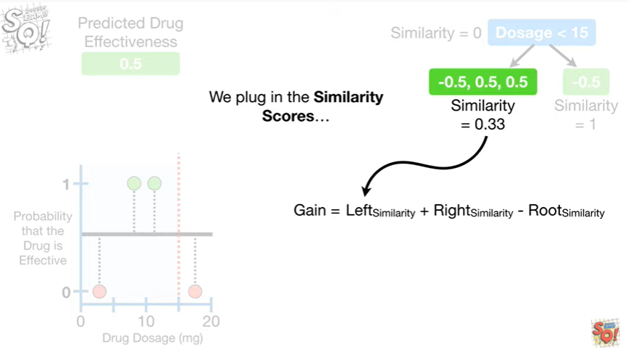

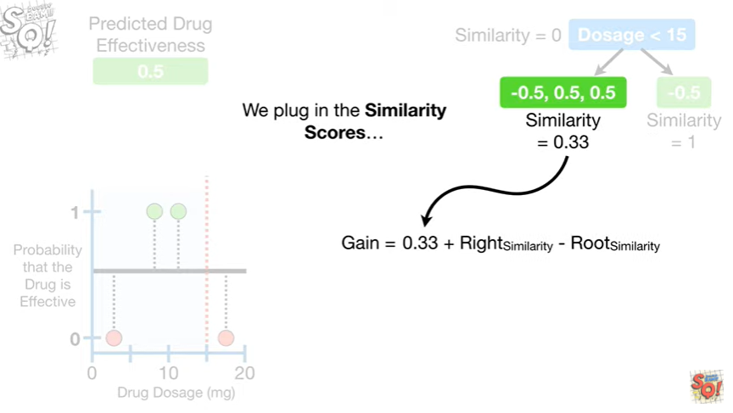

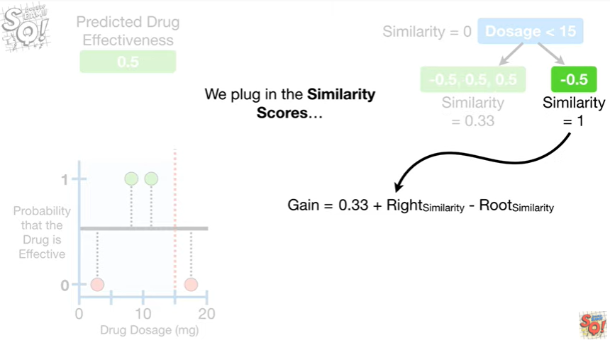

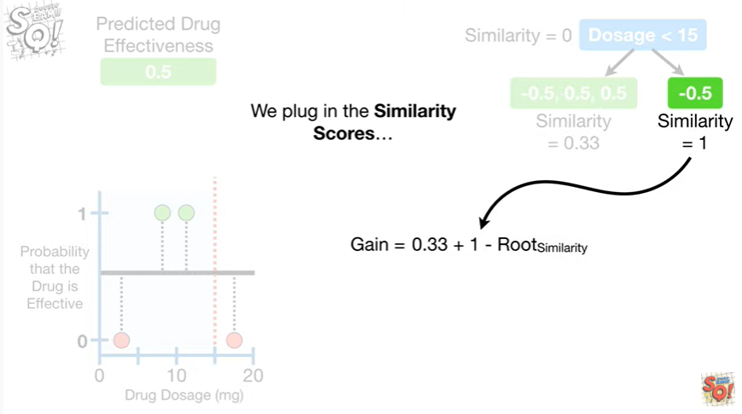

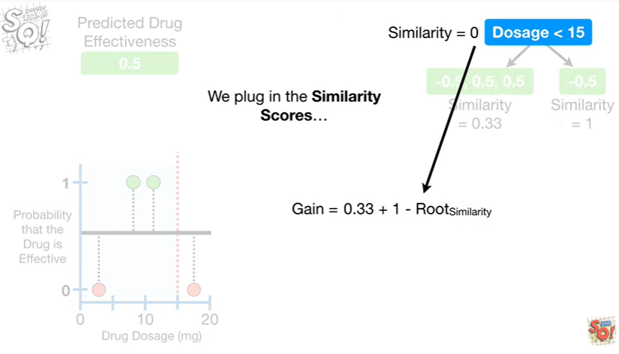

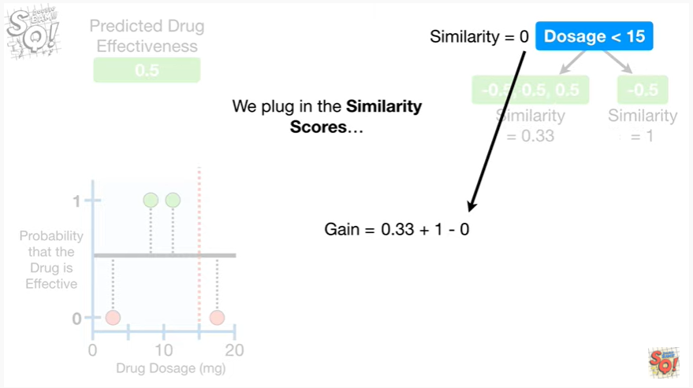

We plug in the similarity scores

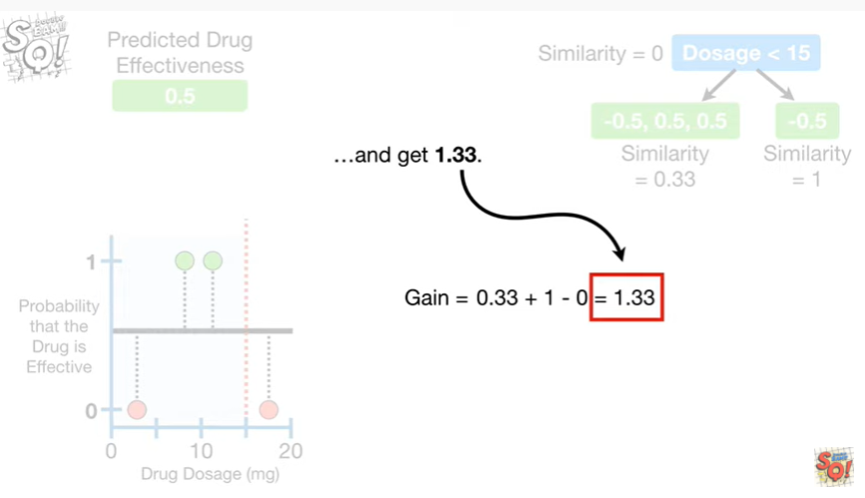

and get 1.33.

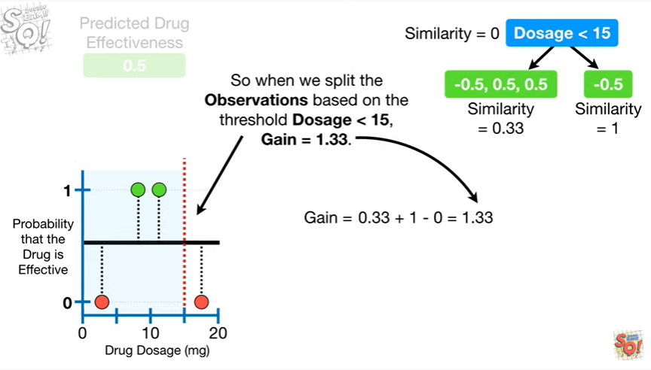

So when we split the observations based on the threshold dosage less than 15 gain equals one point three three.

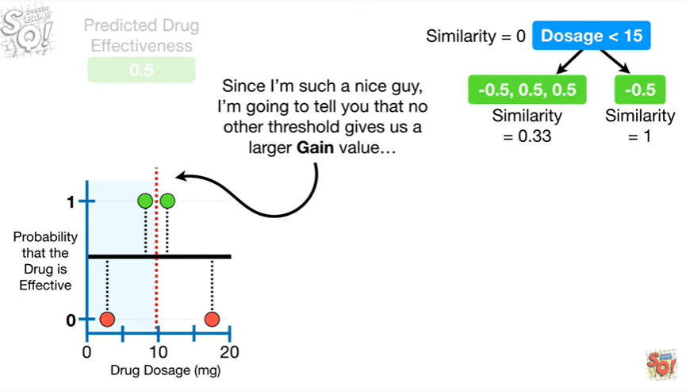

Since I'm such a nice guy, I'm going to tell you that no other threshold gives us a larger gain value

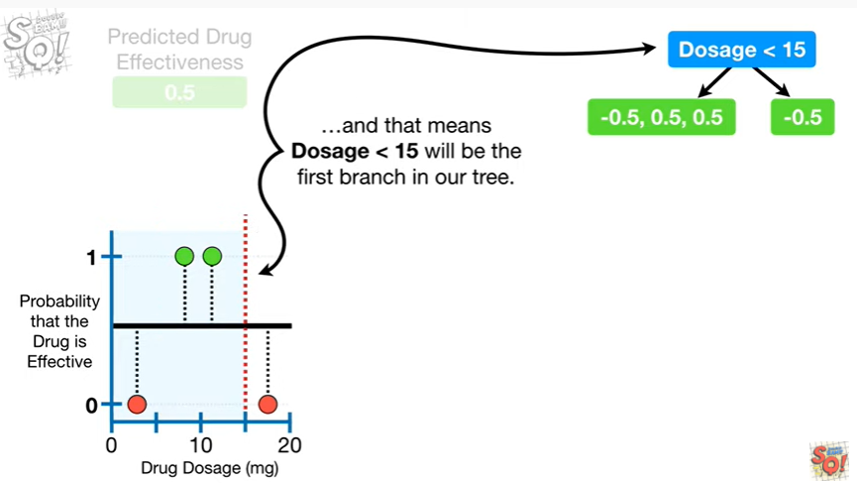

and that means dosage less than 15 will be the first branch in our tree.

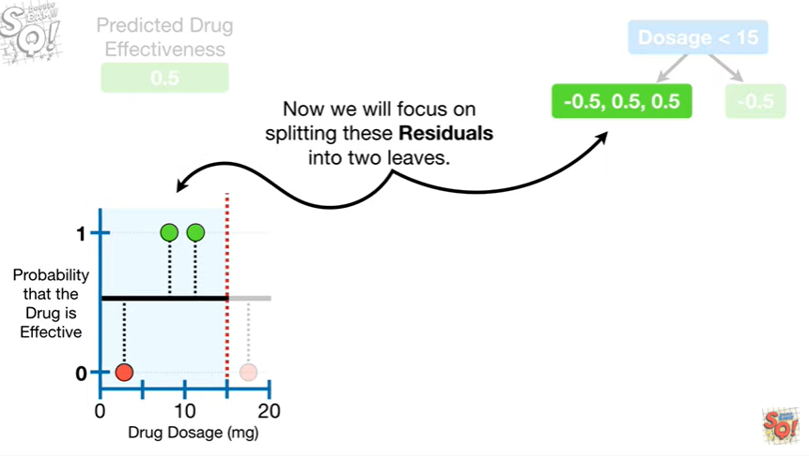

Now we can focus on splitting these residuals into two leaves.

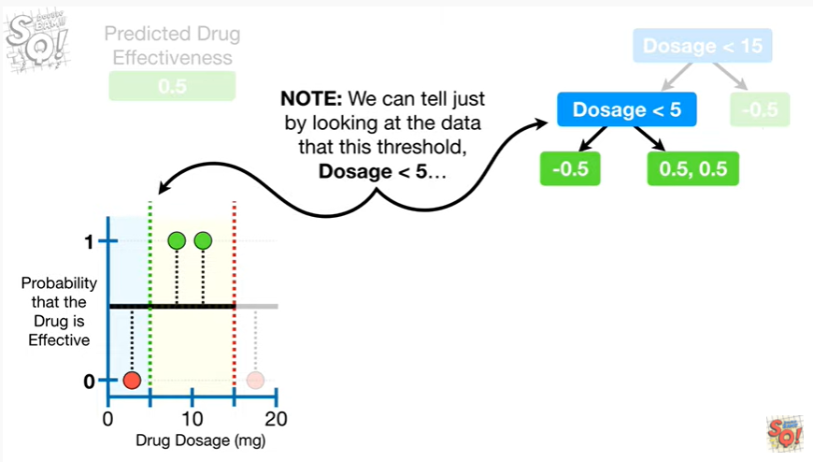

Note : we can tell just by looking at the data that this threshold dosage less than five

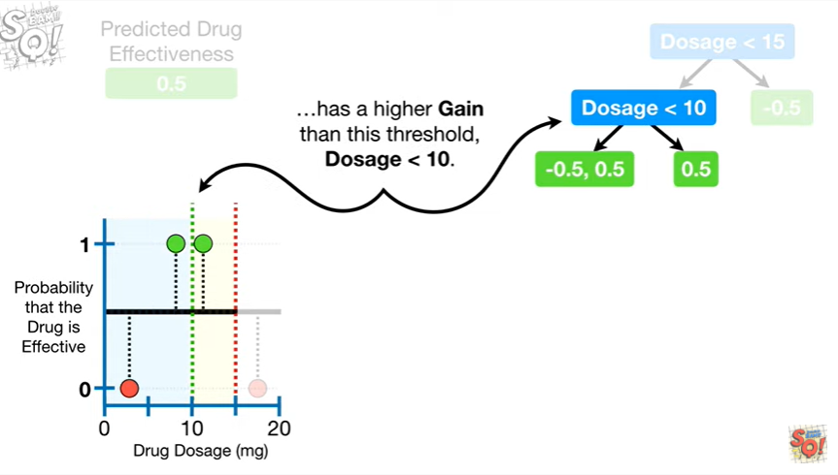

has a higher gain than this threshold dosage less than ten.

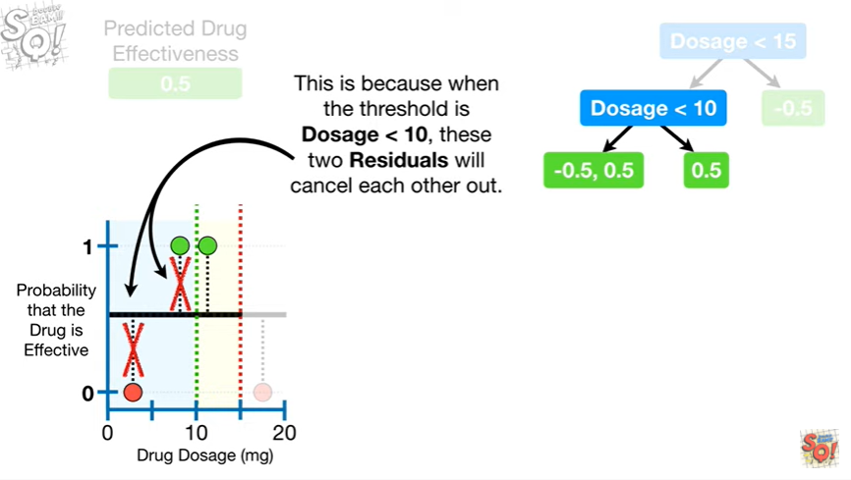

This is because when the threshold is dosage less than ten, these two residuals will cancel each other out

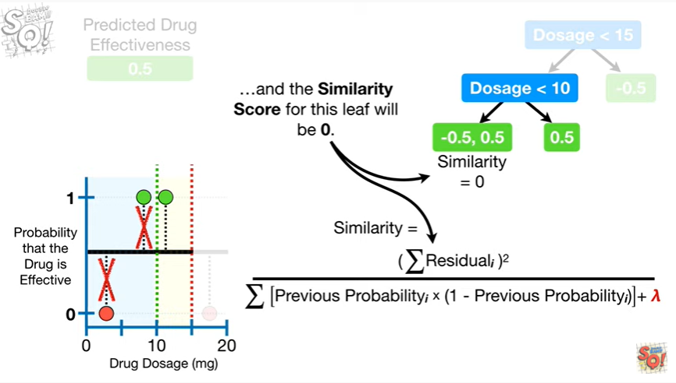

and the similarity score for this leaf will be zero.

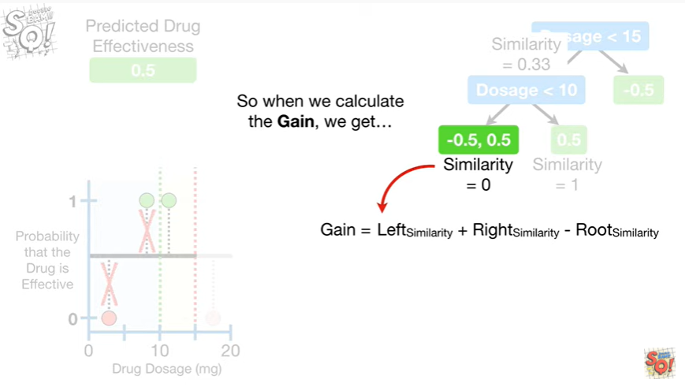

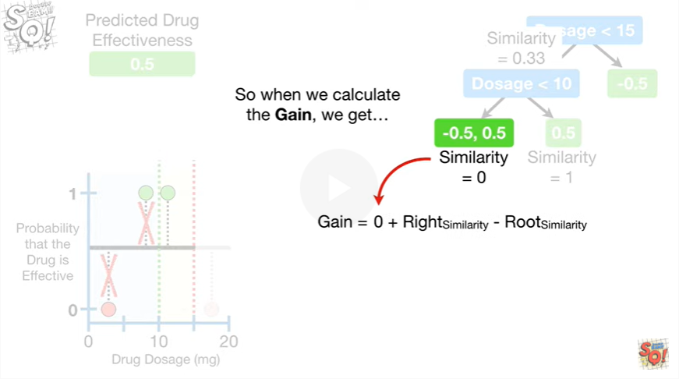

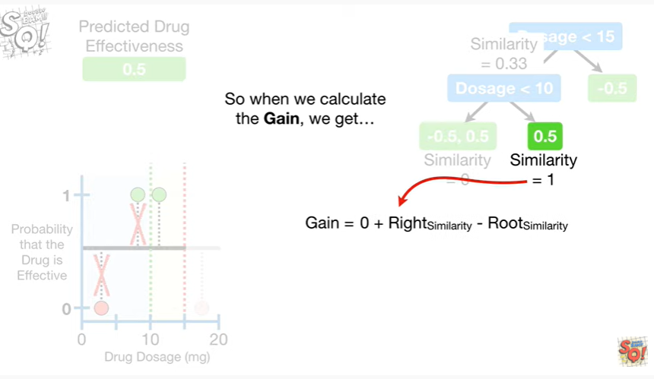

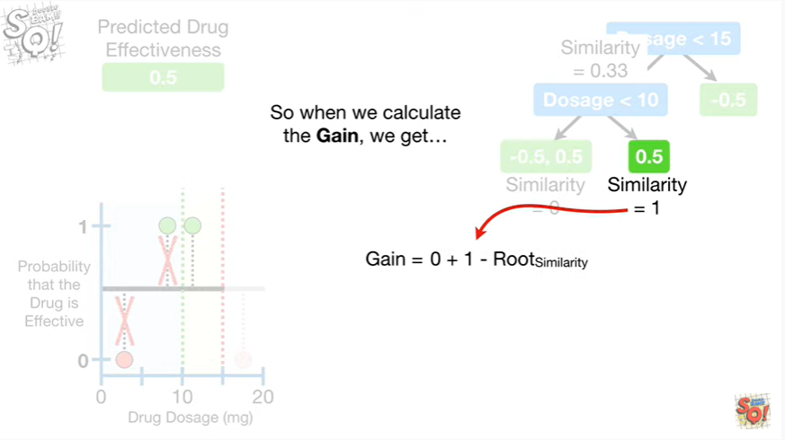

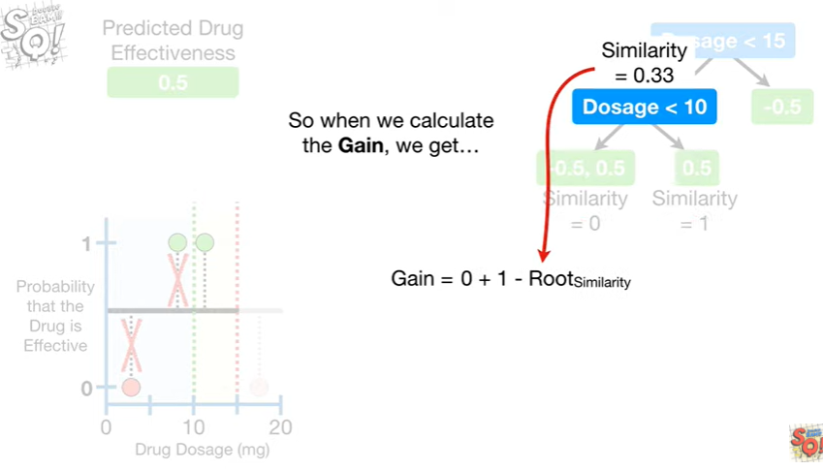

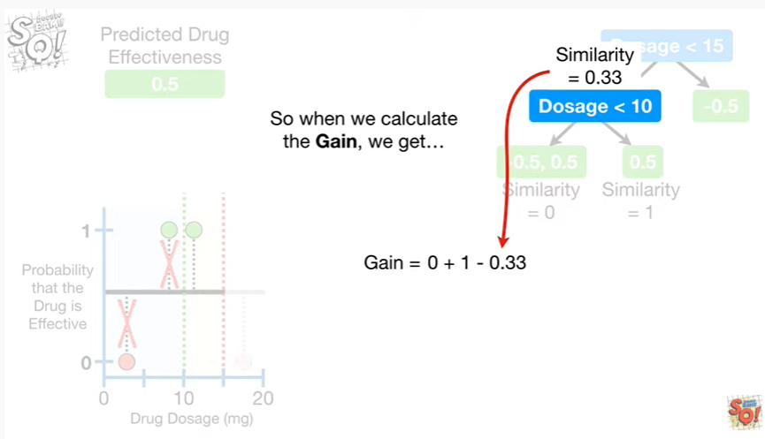

So when we calculate the gain, we get

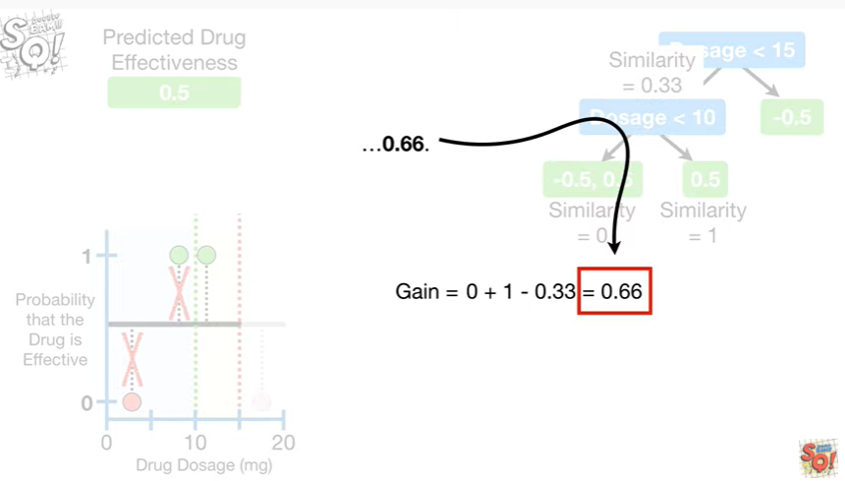

zero point six six.

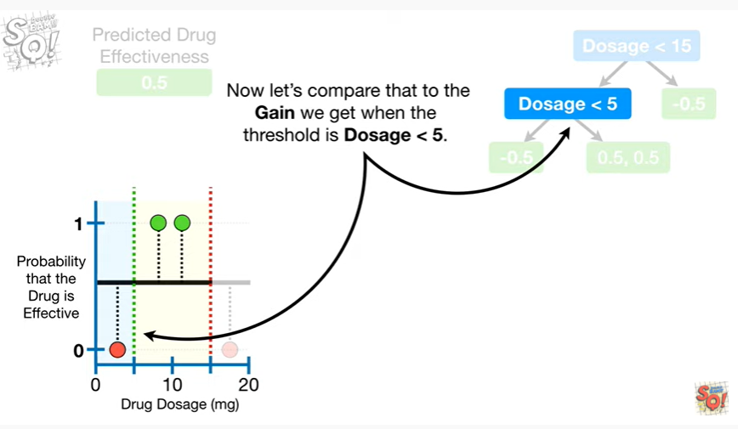

Now let's compare that to the gain we get when the threshold is dosage less than five.

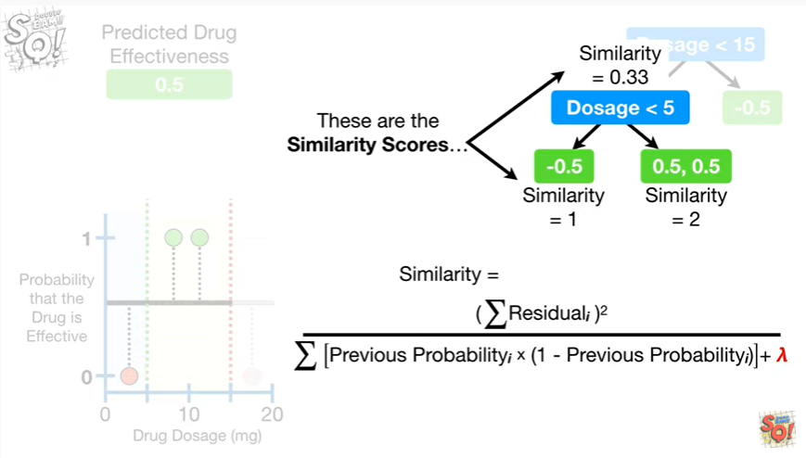

These are the similarity scores

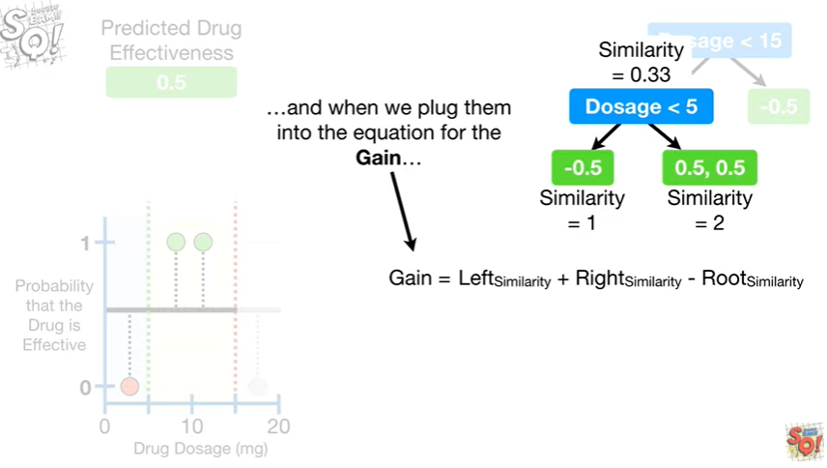

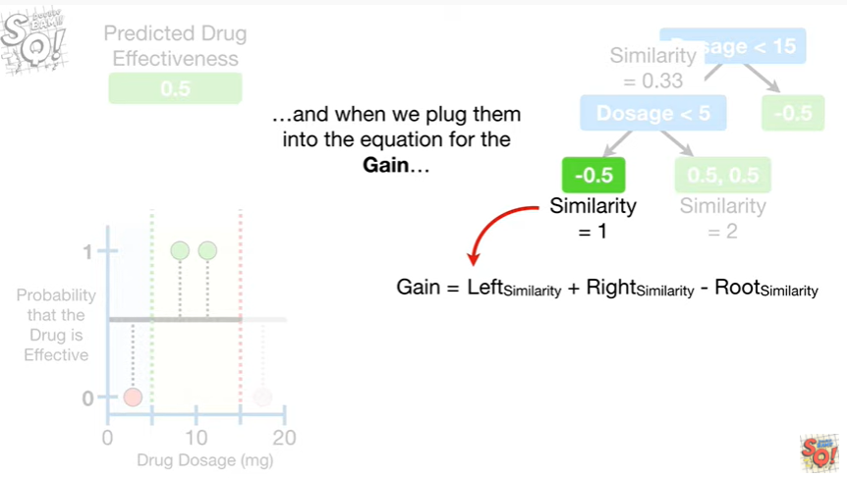

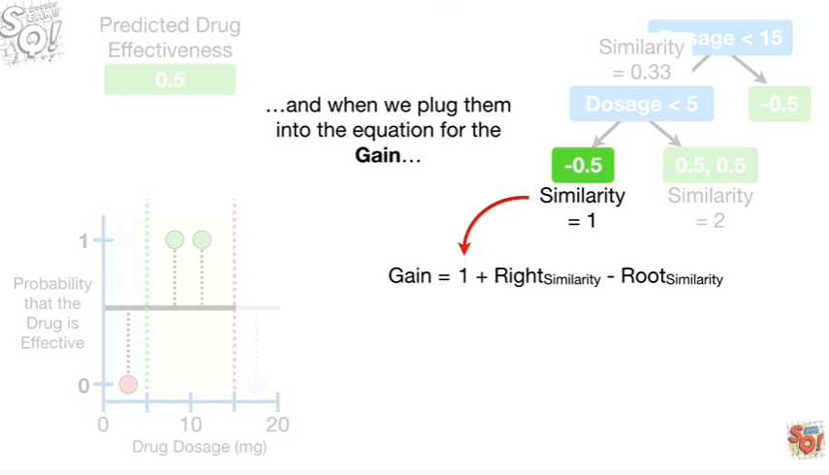

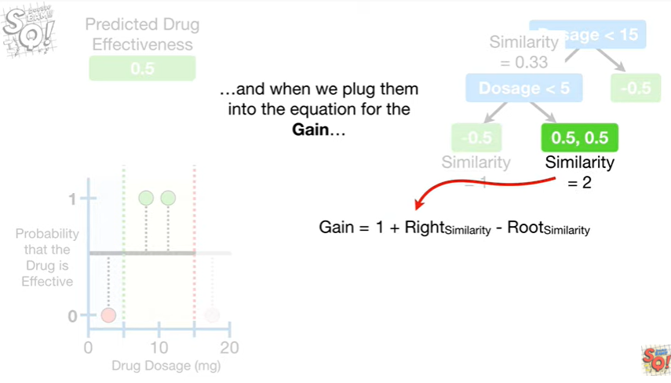

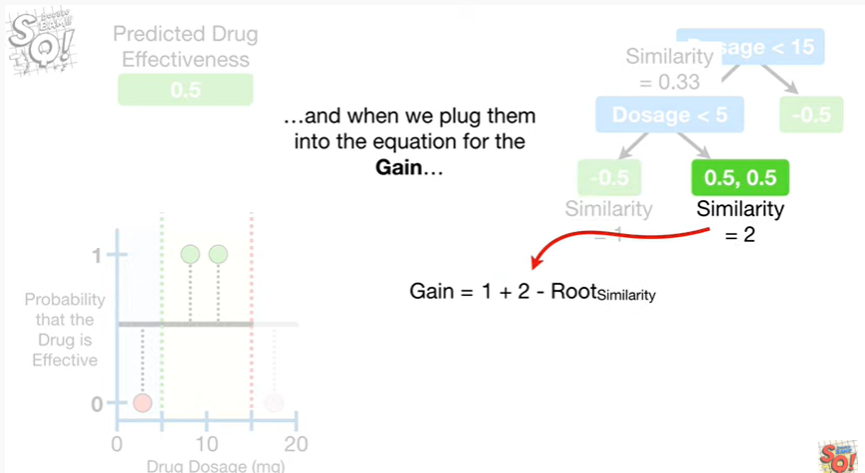

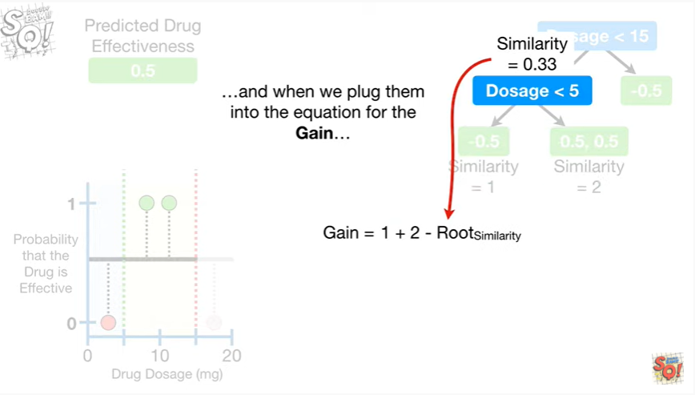

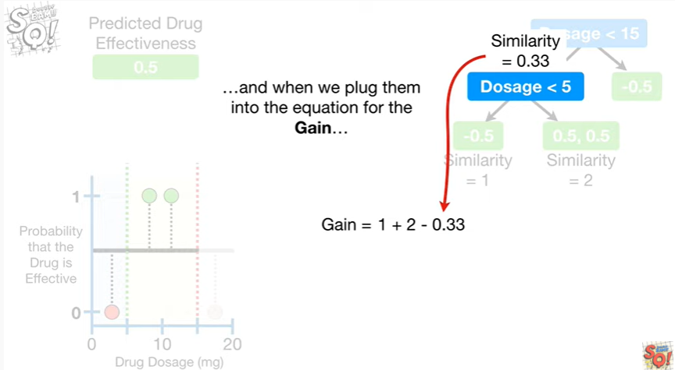

and when we plug them into the equation for the gain

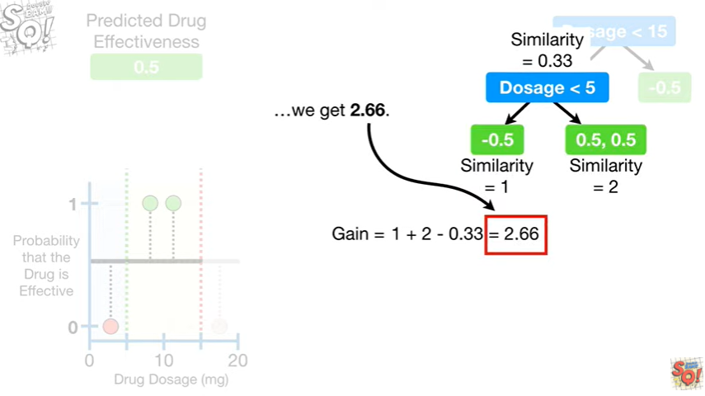

we get two point six six.

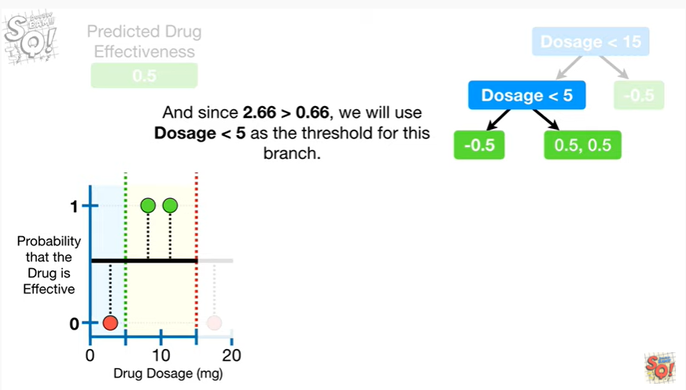

And since two point six six is greater than zero point six six, we we use dosage less than five as the threshold for this branch.

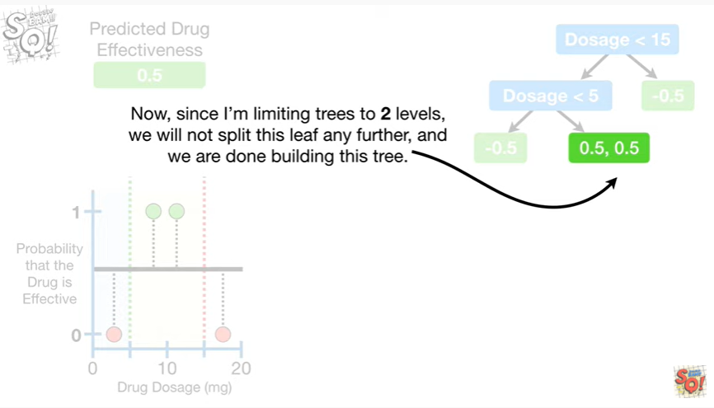

Now, since I'm limiting the trees to two levels, we will not split this leaf any further,

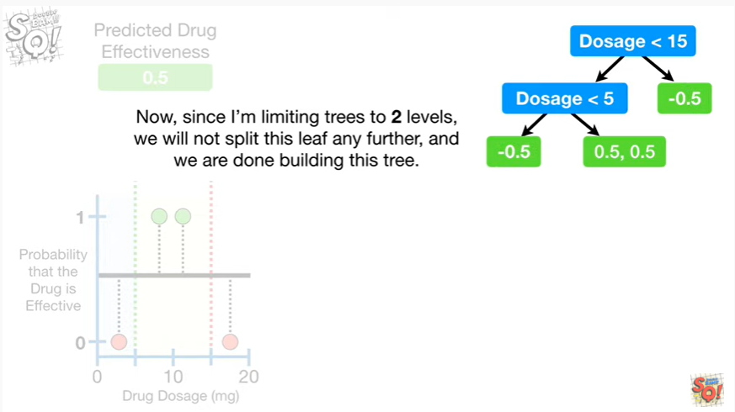

and we are done building this tree.

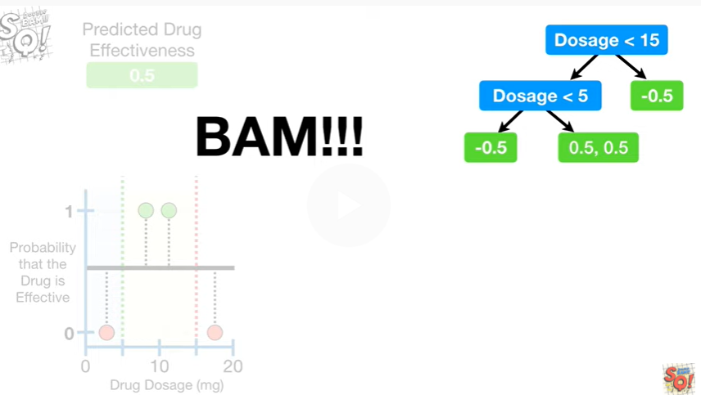

BAM !!!

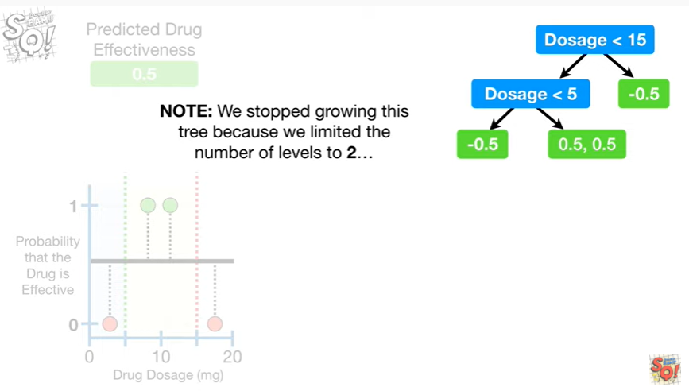

Note : we stopped growing this tree because we limited the number of levels to two

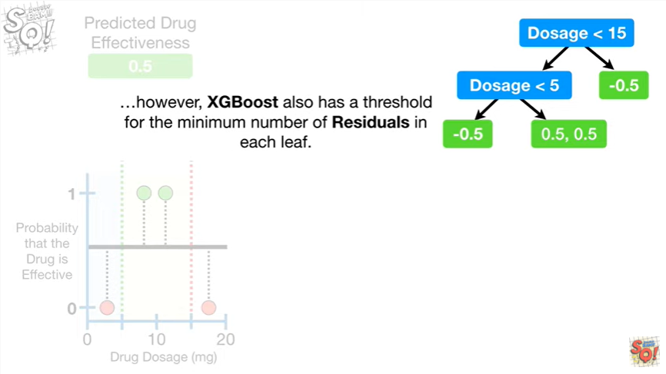

However, XGBoost also has a threshold for the minimum number of residuals in each leaf.

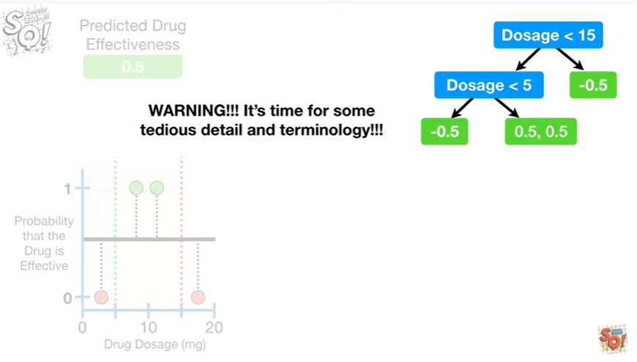

Warning !!!!

It's time for some tedious detail and terminology !!!

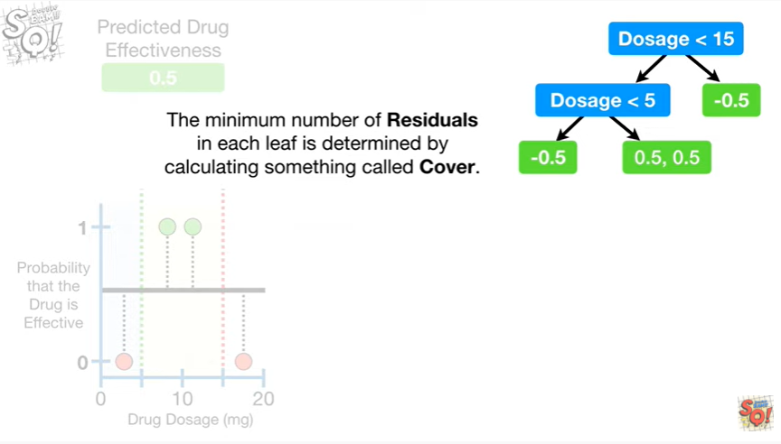

The minimum number of residuals in each leaf is determined by calculating something called cover.

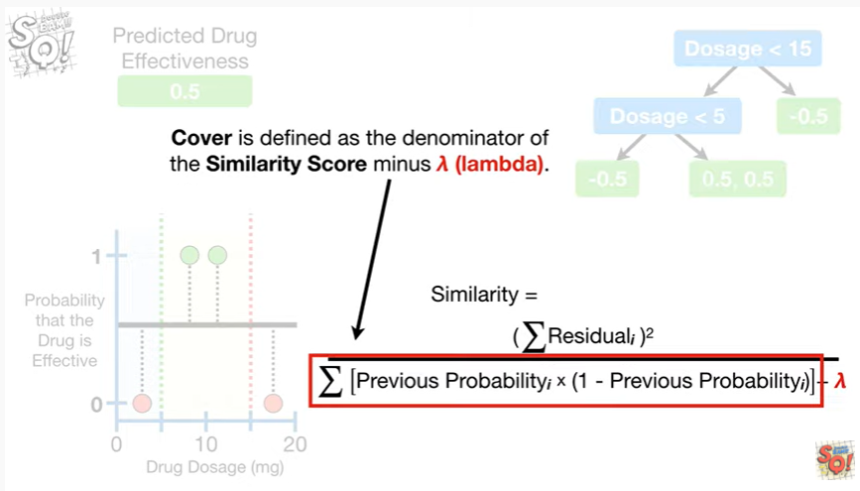

Cover is defined as the denominator of the similarity score minus lambda.

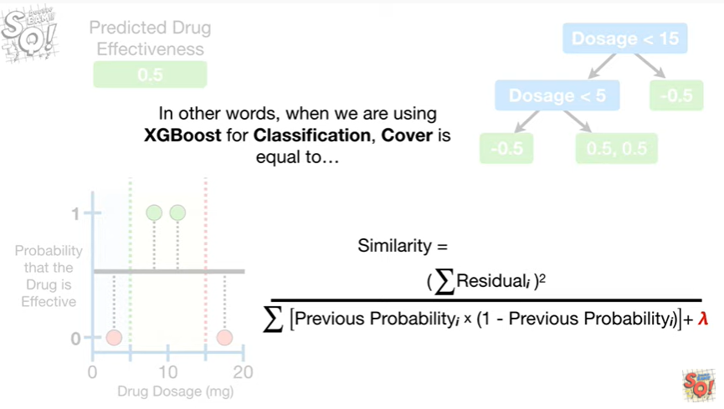

In other words, when we are using X G boosts for classification cover is equal

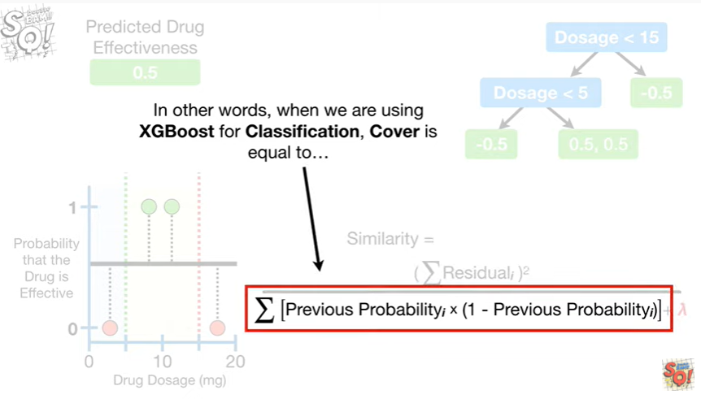

to the sum of the previous probability times 1 minus the previous probability for each residual that's in the leaf.

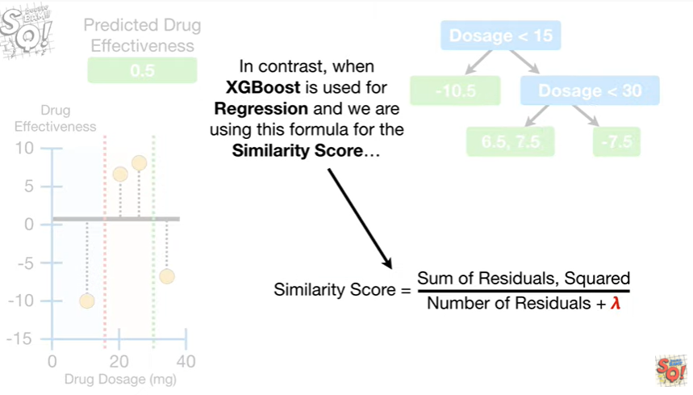

In contrast, when XGBoost is used for regression and we are using this formula for the similarity score

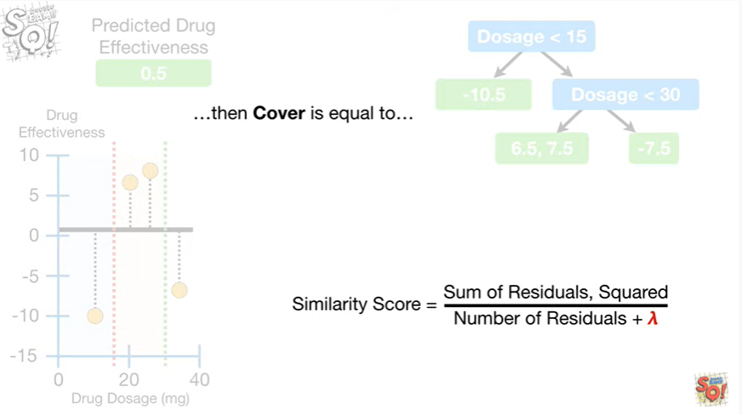

then cover is equal to

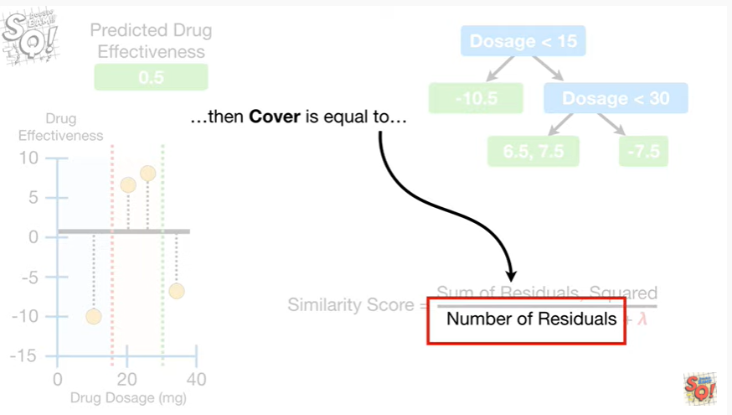

the number of residuals in a leaf.

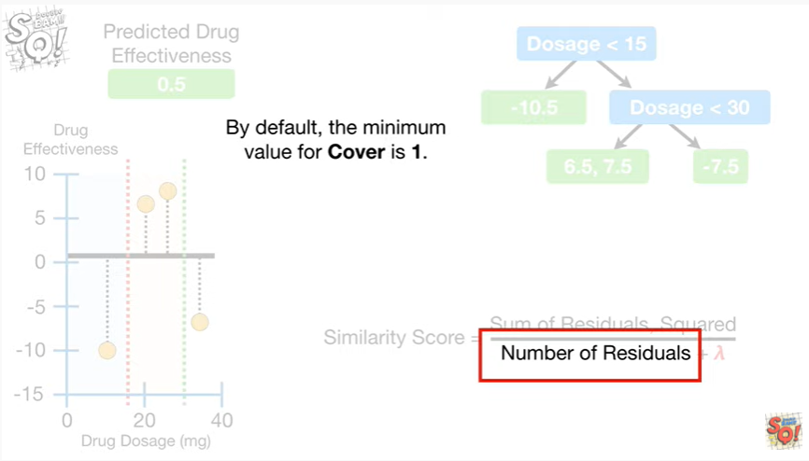

By default the minimum value for cover is one.

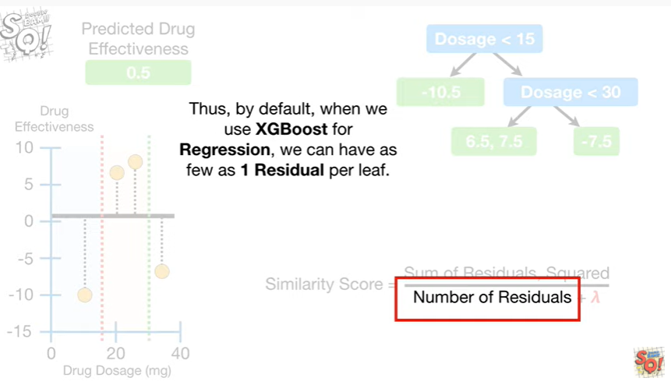

Thus, by default, when we use XGBoost for regression, we can have as few as one residual per leaf.

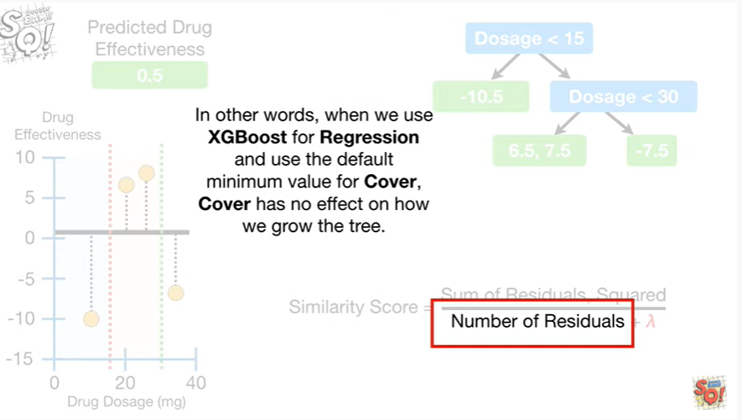

In other words, when we use XGBoost for regression and use the default minimum value for cover cover has no effect on how we grow the tree.

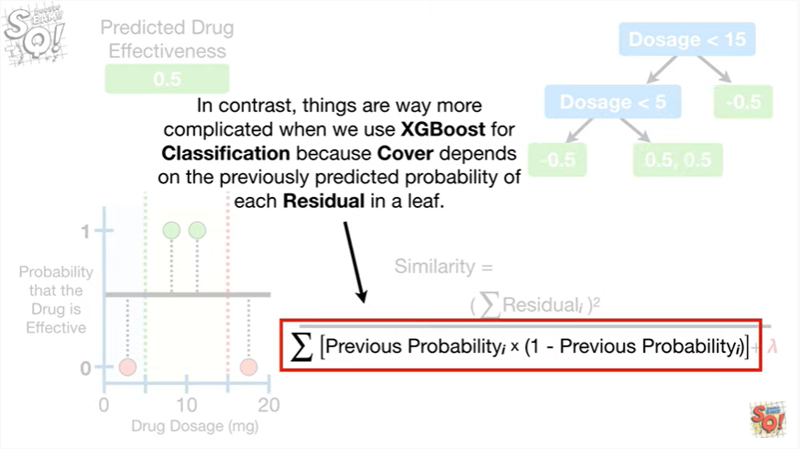

In contrast, things are way more complicated when we use XGBoost for classification, because cover depends on the previously predicted probability of each residual in a leaf.

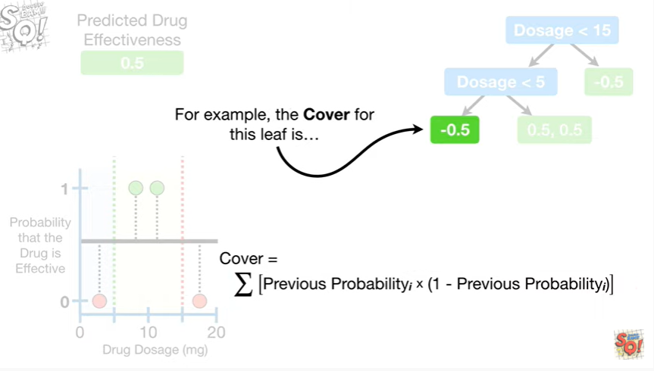

For example, the cover for this leaf is

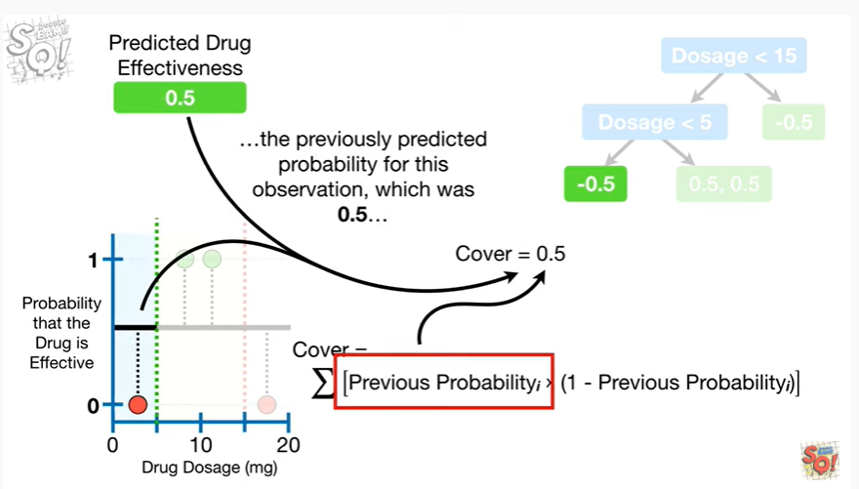

the previously predicted probability for this observation which was 0.5

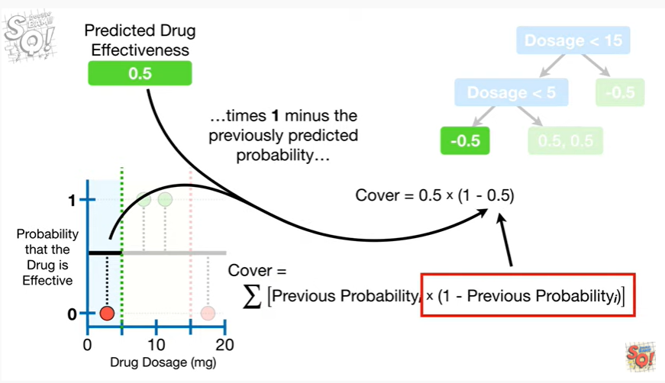

times 1 minus the previously predicted probability

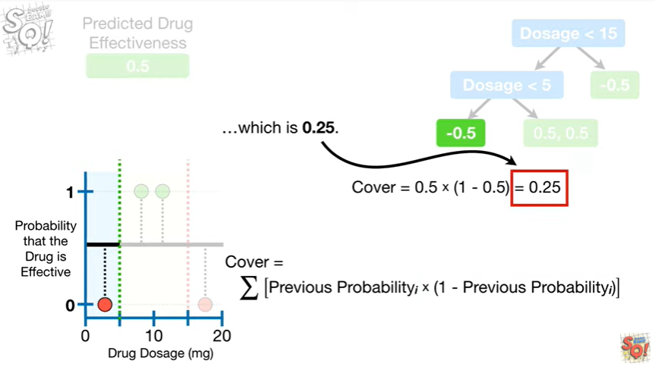

which is 0.25.

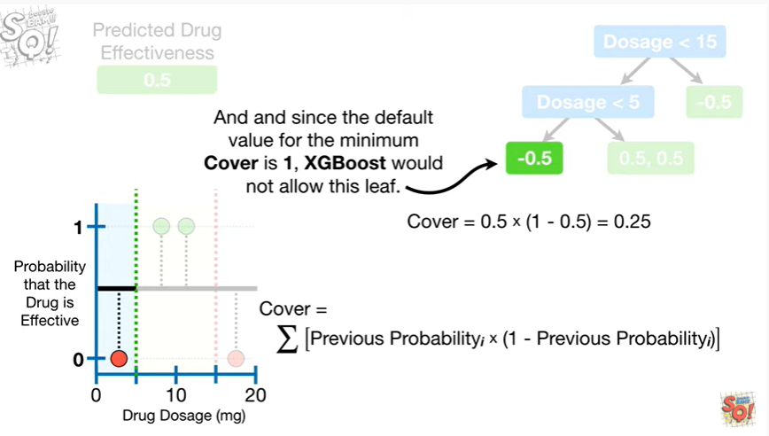

And since the default value for the minimum cover is 1, XGBoost would not allow this leaf.

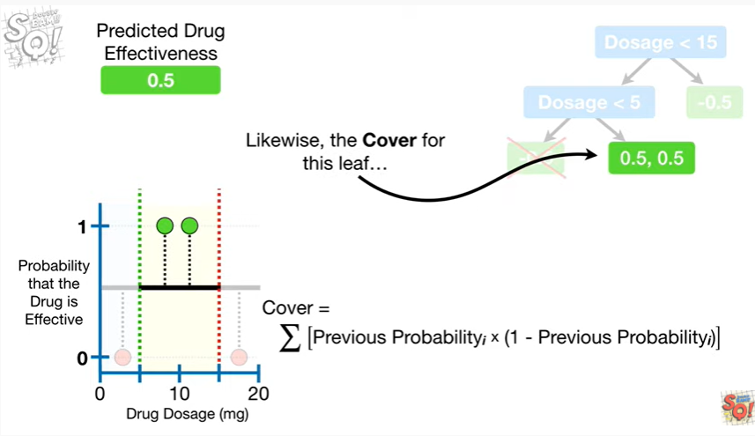

Likewise, the cover for this leaf

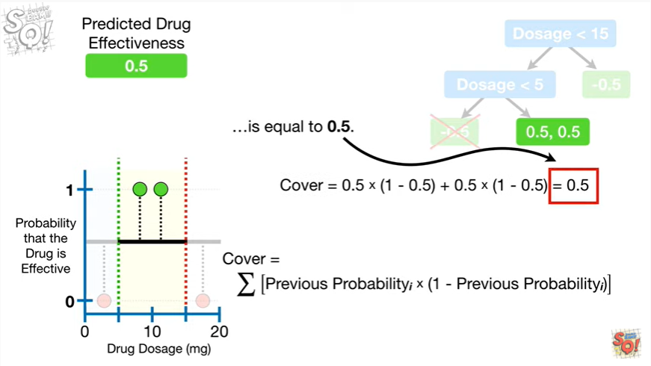

is equal to 0.5.

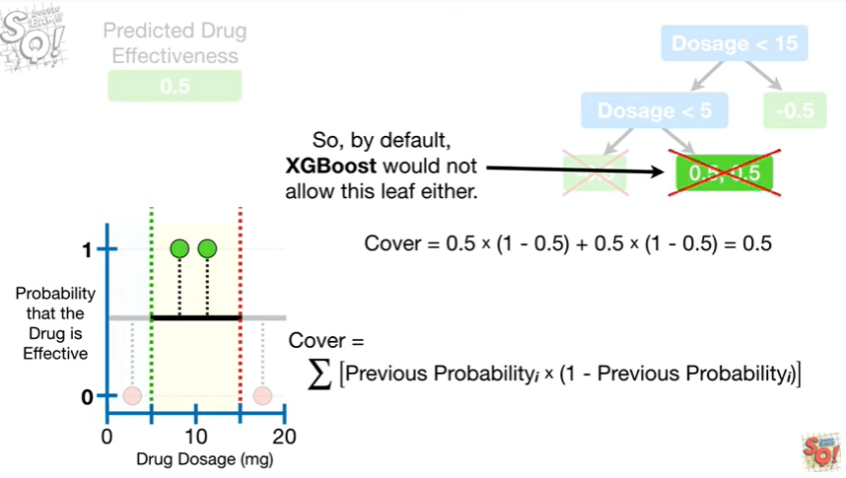

So by default, XGBoost would not allow this leaf either.

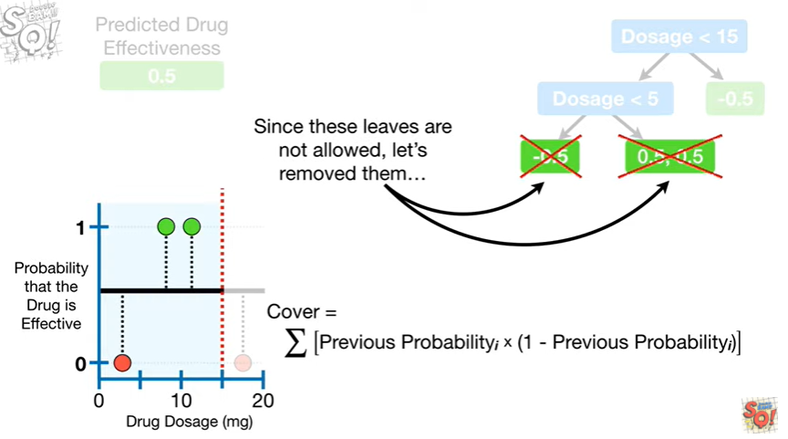

Since these leaves are not allowed let's remove them

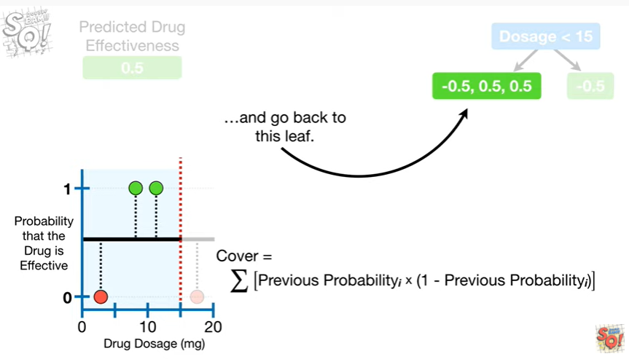

and go back to this leaf.

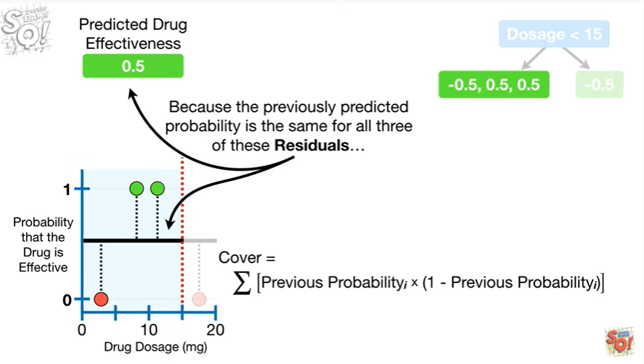

Because the previously predicted probability is the same for all three of these residuals

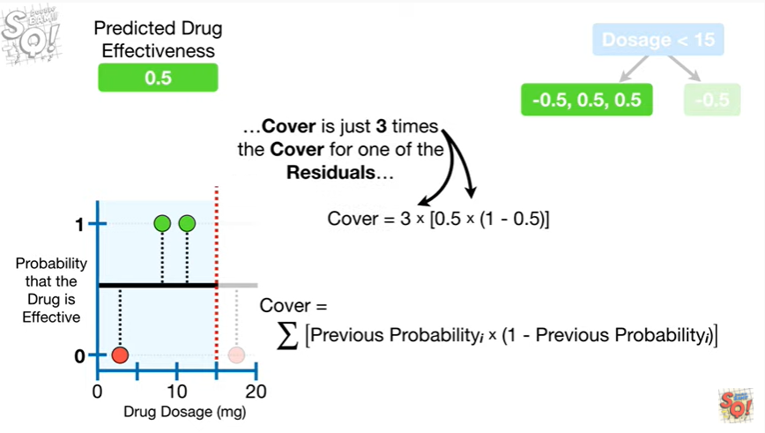

cover is just 3 times the cover for one of the residuals